**Lise Meitner – Physicist**

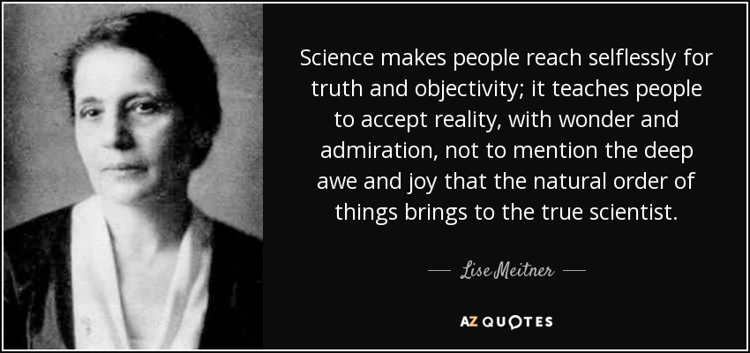

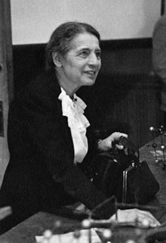Lise Meitner (November 1878 to October 1968) was an Austrian-Swedish physicist who studied radioactivity and nuclear physics. She first began studying science and math when she was 8 years old. She kept a notebook of her observations under her pillow. Women were not allowed to study at high education institutions in 1900, but with her parents support financially she was able to attend a private institution. She attended the University of Vienna in 1901 to study physics, and graduated with her doctorate degree in 1906, and then went to Berlin to study chemistry with Otto Hahn. With Meitner’s knowledge in physics and Hahn’s knowledge in chemistry, they came together to study radioactivity. In 1912 she worked with a research group in Berlin, but was not paid salary, and worked as a “guest” in Hahn’s department of Radiochemistry. It was not until 1913 that she got a permanent position. In 1918 she discovered the element protactinium. In 1938 she was forced to flee Germany, but she continued to work at Manne Siegbahn’s institute in Stockholm, despite the struggles she faced and the prejudice against women in science. In 1939, she and a small group of scientists discovered nuclear fission of Uranium. Nuclear fission is the basis of nuclear weapons and is also used by nuclear reactors to generate energy. Additionally, Lise Meitner was also the first woman physics professor in Germany at the Kaiser Wilhelm Institute, where she also became a department head. She even has a chemical element, Meitnerium, named after her!