FAST Financials – Query Basics-Using Public Queries

The goal

This document will provide basic knowledge for running USF public queries in FAST.

Consider

A large number of queries currently exist in FAST to help you manage your funds and transactions. Queries may be either private and attached to your FAST ID or public for any user to use.

Most USF public queries are recognizable; they are named as U_xxxxxxx. A USF public query may be saved and renamed as a private query by any user.

There is a list of commonly used public queries on the Controller’s Office web site: www.usf.edu/business-finance/controller . Find the document under “About UCO/Library of Resources”.

A private query may be copied to any other FAST user. That FAST user may then modify the query to suit their needs or use it as is.

This document, as an introduction to queries, illustrates how to view a public query, how to make minor enhancements to a public query, how to copy a public query to your ID as a private query, and how to copy a private query to another user. A separate document addresses the creating of private queries.

Contents

Exercise 1 Running an existing public query Page 2

Exercise 2 Adding criteria to limit the results Page 7

Exercise 3 Copying a public query as a private query Page 12

Exercise 4 Viewing a list of your private queries Page 15

Exercise 5 Copying a private query to another user Page 16

Recap Page 19

Last Revision - May 9, 2017
Exercise 1: Running an Existing Public Query

Step 1 To find an existing query, navigate through Reporting Tools/Query/Query Manager

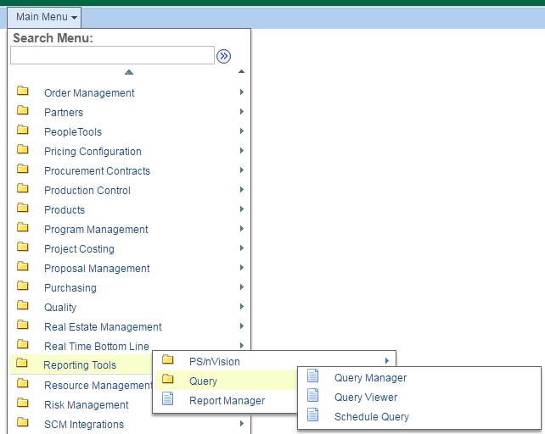

Step 2 A search page will present. If you know the full exact name of the query, enter that name in the search box (the box to the right of the phrase “begins with” and click the button.

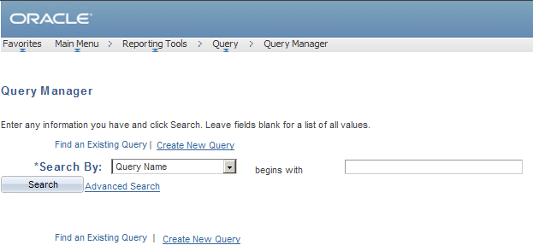

For instance to locate the query that identifies Sponsored Research staff who are involved with the financial management of a grant project, you could type the following query name:

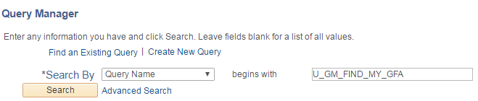

Public queries such as this one are usually prompt driven. Once you locate the query and run the query, a set of prompt fields will appear which you would use to specify the parameters of your report.

Step 3 If you do not know the full exact query name, the best way to search is with a shred of the query name using the “Advanced Search” feature.

Step 4 In this exercise, we will run the query for identifying the cash balance in a fund. Click the Advanced Search option to navigate to the search page (below). In the Query Name field, change the operator to “contains” and then type the word “cash”. Click SEARCH.
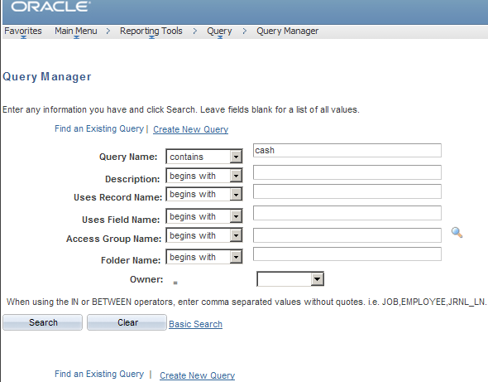

A list of queries containing the word cash will be displayed in alphabetical order. Notice that some of the queries below begin with “U_”; these are USF designed queries. The others that do not begin with “U_” are PeopleSoft delivered queries and will not be useful. Some users may see fewer or more queries delivered; the search results will include the user’s private queries.

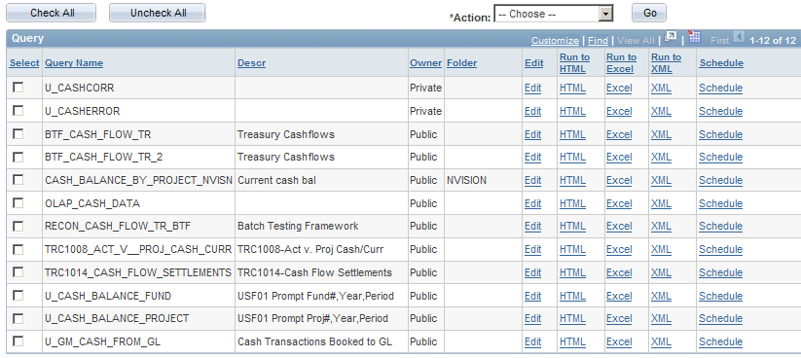

Once you have located the query, in this example U_CASH_BALANCE_FUND, click the Excel hyperlink to run the query.

Note that there are “Select” boxes to the left of each query name. This box is not needed to run the query but the select box does have a use that will be addressed later.

Step 5 A “Prompt” box may appear. Prompts are not required but often are added to public queries when specific values are required. In this query, a Fiscal Year, Accounting Period, and Fund ID are needed. All three are required because this query will identify the cash balance for any specific point in time for a particular fund. Complete the prompt box as illustrated below. If a prompt box does not appear, simply clicking Excel will run the query. Click to complete the query action.

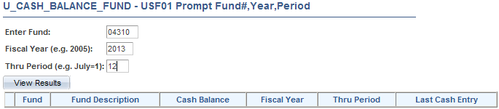

An open/save box will appear. Click the “Open” button.

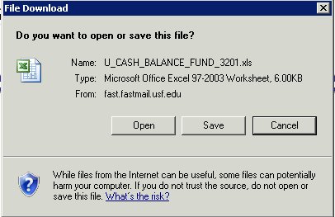

The results will appear as illustrated below.

 A few helpful tips
√ It is best and easiest to search for a full, exact query name. However if you do not know the full query name, you have two options.
√ The first option is to search for “Query Name begins with”; then enter as much of the beginning of the query name that you know.
√ The second option is to use the advanced search feature. This allows you to search for a shred of the query name using the Query Name contains” feature. For instance if the query name is U_CASH_BALANCE_FUND, you could search query name contains “cash” to view a list of all queries that contain the word cash.
√ Most public queries that have been written by USF begin with “U_”.
√ Remember that you may save pages in FAST as favorites; this will save you the effort of remembering the navigation steps.

Exercise 2: Adding Additional Criteria to Limit the Results: You may need to add, modify or remove criteria from a public query on occasion. This can be done easily and these changes are temporary. Once you exit the query, it reverts to its original state. For illustration, use the query named U_CF_ACCOUNT which produces a list of GL account codes.

Step 1 To find an existing query, use the left-hand navigation menu. Select “Reporting Tools” and drill down through the “Query” folder to the “Query Manager” hyperlink. Click “Query Manager”.

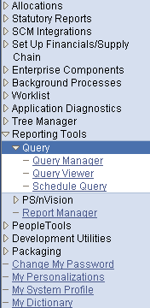

Step 2 If you know the full exact name of the query, enter that name in the search box and click the button. In this illustration we will look for U_CF_ACCOUNT.

If you do not know the full exact query name, remember that you can use the “Advanced Search” feature to find a query by using a shred of the name. See tips for this search method in Exercise 1, steps 3 and 4.

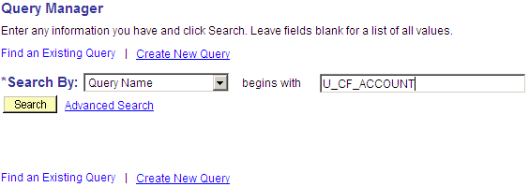

Step 3 When the query name appears, click the button.

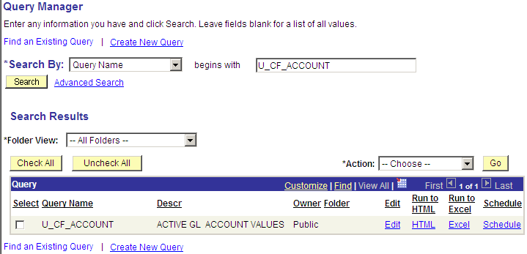

Step 4 Once you have opened the query, click the “Criteria” tab. You will see all current criteria displayed. In this illustration, there are 3 criteria currently; the effective date, the status, and the SetID.

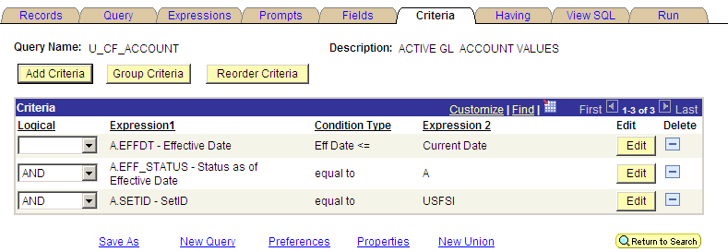
Step 5 To add additional criteria, click the button. You will see the criteria setup page appear (illustration below).

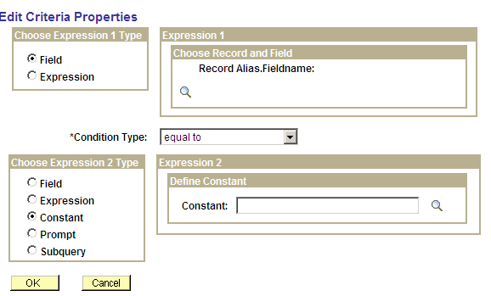

Step 6 Remember that criteria are a filter to customize the results of the criteria. For this illustration, build criteria that will result in a report of only those GL account codes that begin with a “1”.

First choose field name. Click the search button to reveal a list of all available fields. In this illustration the “Account” code is selected.

Next select the condition type. To build a condition to search for account codes that begin with a particular digit, select the expression “like”.

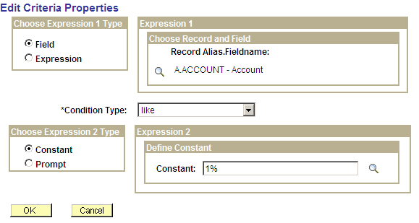

These are the available condition options.

Between | The value in the selected record field falls between two comparison values. The range is inclusive.
Equal To | The value in the selected record field exactly matches the comparison value.
Exists | This operator is different from the others, in that it does not compare a record field to the comparison value. The comparison value is a subquery. If the subquery returns any data, PeopleSoft Query returns the corresponding row.
Greater Than | The value in the record field is greater than the comparison value.
In List | The value in the selected record field matches one of the comparison values in a list.
Is Null | The selected record field does not have a value in it. You do not specify a comparison value for this operator. Key fields, required fields, character fields, and numeric fields do not allow null values.
Less Than | The value in the record field is less than the comparison value.
Like | The value in the selected field matches a specified string pattern. The comparison value may be a string that contains wildcard characters. The wild-card characters that PeopleSoft Query recognizes are % and _. % matches any string of zero or more characters. For example, C% matches any string starting with C, including C alone.  % matches any string of zero or more characters. For example, C% matches any string starting with C, including C alone.

Finally select the constant. Note the use of the wild card “%” sign. In this illustration since we are looking for codes that begin with a “1”; enter “1%”.

Then click the button to save the new criteria.

Step 7 We now have a query with 4 criteria.

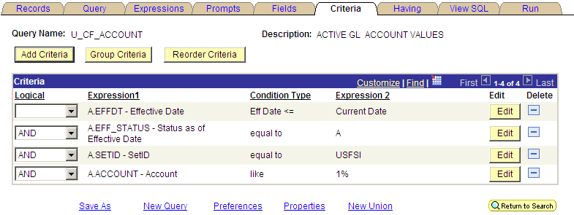

Step 8 Next click “Run” to launch the query; the results will report only GL account codes that begin with a “1”, a total of 135 codes.

You may download the results to an Excel spreadsheet.

You may also click the “Criteria” tab, update the criteria again, and the re-run the query. The actions you have taken will in no way alter the query. Once you navigate away from this page, all changes you made will be lost and the query reverts to its original condition.
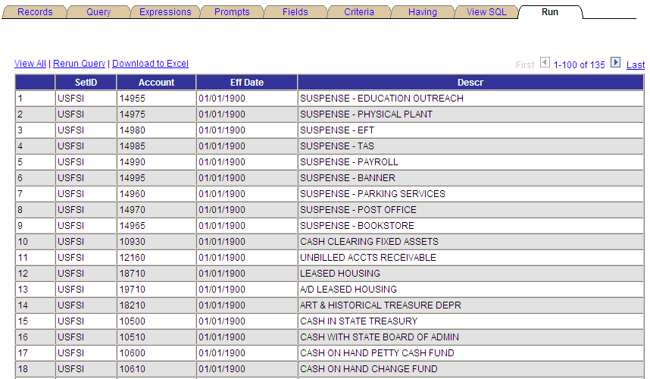

Step 9 Removing criteria is even easier. Navigate to the Criteria tab (as in step 4 above).

Step 10 To remove any criteria, just click the button to the right of the specific criteria and it will instantly disappear.

Exercise 3: Copying a Public Query as a Private Query: A public query may be copied as a private query which you can then modify to suit your needs. But be careful. Before making any changes examine the query carefully to understand how it was designed and make sure you have sufficient knowledge to modify it.

Step 1 Navigate in FAST through: Reporting Tools - Query - Query Manager.

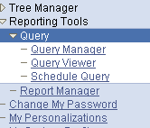

Step 2 If you know the full exact name of the query, enter that name in the search box and click the button.

If you do not know the full exact query name, remember that you can use the “Advanced Search” feature to find a query by using a shred of the name. See tips for this search method in Exercise 1, steps 3 and 4. This illustration uses the query U_PAYMENTS_BY_AMOUNT.

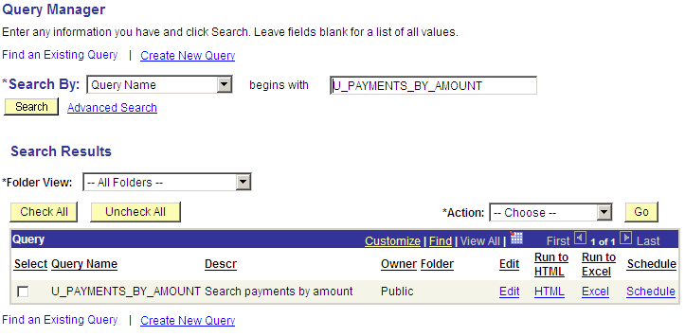

Step 3 Click the “Edit” button to call up the query.

Step 4 Click the “Save As” button; then enter the new name for the query. Then click the “OK” button.

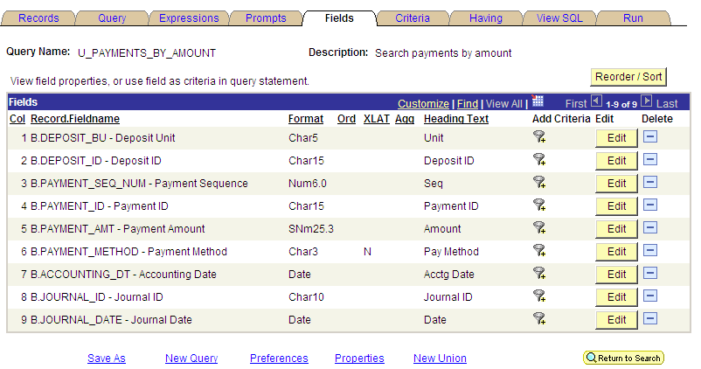

Type a new name for the query (in this illustration we added ALT to the name) and click the “OK” button. A new copy of the query is created using the new name; it will be a private query linked to your FAST user ID.

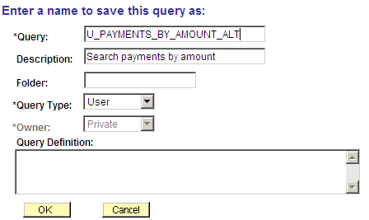

Exercise 4: Viewing a list of your private queries: You may easily view a list of your own private queries. You do not need to remember the exact names of your queries.

Step 1 Navigate in FAST through: Reporting Tools - Query - Query Manager.

Step 2 Search using the Advanced Search method. Click Advanced Search.

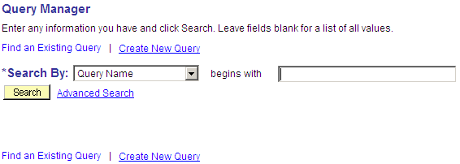

Step 3 From the drop-down menu in the “Owner” field, select the “private” option. Click “Search”.

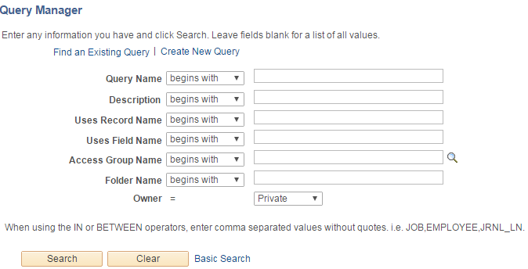

Step 4 You will then see a list of your private queries which you may run or edit as needed.

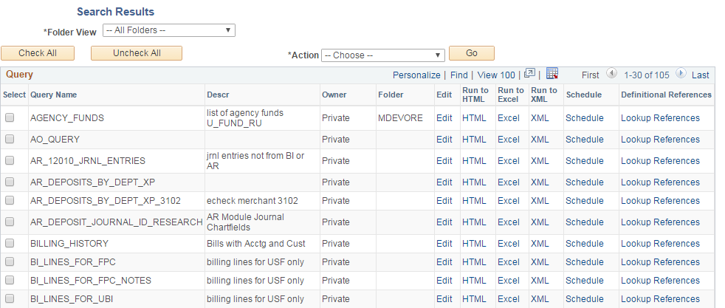

Exercise 5: Copying a Private Query to Another User: If you want to share a private query with another user or if another user wants to share one with you, the query can be copied from one user to another. Queries can only be shared with someone who has a valid FAST ID. It is simpler than it sounds.

Step 1 Navigate in FAST through: Reporting Tools - Query - Query Manager.

Step 2 If you know the full exact name of the query, enter that name in the search box and click the button.

If you do not know the full exact query name, remember that you can use the “Advanced Search” feature to find a query by using a shred of the name. See tips for this search method in Exercise 1, steps 3 and 4.

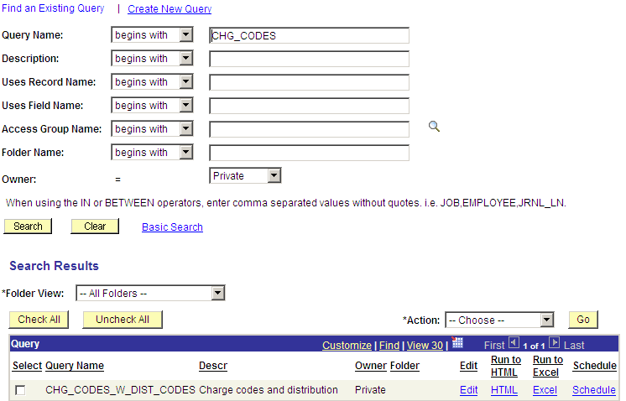

Step 3 Check the select box to the left of the query name that you wish to share with another user. You must check the select box even if only one query name appears as in this illustration.

Then select the “Copy to User” option from the “Action” box options.

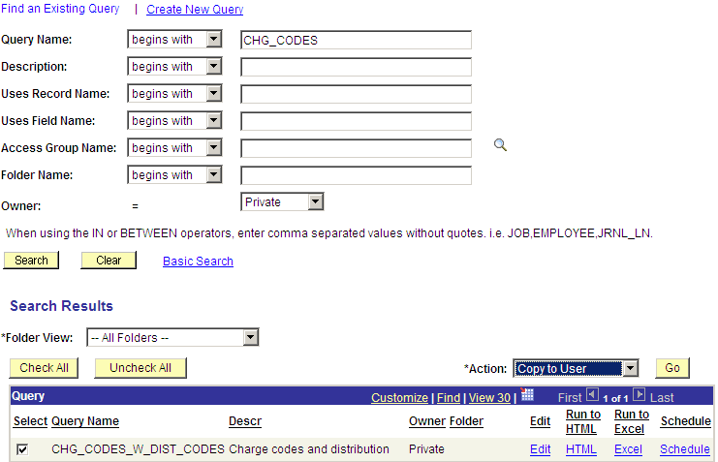

Step 4 Click the “Go” button, then enter the FAST user ID of the person to whom you wish to copy the query.

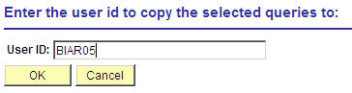 Then click the “OK” button.

You will then be presented with a confirmation message that the query has been copied to
another FAST user.

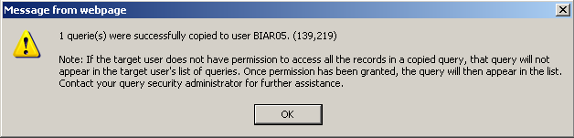

A Recap

