Creating a Journal Entry
In FAST

Finance and Account


Information compiled and prepared by:

Controller's Office, University of South Florida
www.usf.edu/business-finance/controller

Last update: January 31, 2020

Contents – Creating Journal Entries for Posting in FAST

Requirements |  | 2
Overview |  | 2
Format |  | 2
Non-payroll Expenditure Transfer |  | 3
Interdepartmental Billings |  | 4
Submission of Request |  | 6
Frequently Asked Questions |  | 7
Resources/Contact Information |  | 8

Requirements

Requests for journal entries must be presented using the USF journal entry template in Excel spreadsheet form.

Overview

The USF journal entry template is the official format for requesting a journal entry. Departmental journal entry requests most often relate to either an expenditure transfer, a revenue reassignment or an interdepartmental billing by an auxiliary.

Expenditure transfers (ETR) may address either non-payroll transactions or payroll transactions. In the course of reconciling and reviewing financial transactions, a departmental user may identify an expenditure that is coded to an incorrect chart field string. Correction is made with the journal entry template. The ETR is submitted by email to be reviewed and posted by General Accounting. Additional review and action will be required if one of the chart field strings being used include a sponsored research project chart field. The ETR will need to successfully complete budget checking and combination edit checking.

Interdepartmental billings are prepared by auxiliaries within USF to charge either another USF department or a sponsored research grant for services and products sold by the auxiliary.

Responsibilities

Departments, Centers, and Colleges prepare and submit journal entry requests.

Sponsored Research Post Award will review and assess the appropriateness of non-
payroll expenditure transfers that include a debit or a credit to a grant project or
initiative.

UCO General Accounting will review and assess the appropriateness of non-payroll
expenditure transfers and interdepartmental billings that are not managed by
Sponsored Research Post Award.

UCO General Accounting will post the transaction to the general ledger.

Departments bear the responsibility for reconciliation of the journal entry requests
that they submit.

Format

The journal entry template may be found on the UCO web site; http://www.usf.edu/business-finance/controller/accounting-reporting/gaforms.aspx . The form document includes the template for submission, a sample illustration, and a justification page. This form must not be altered in any way. The form is designed to provide the necessary chart field coding, references to related transactions, and notation to provide adequate support for reconciliation and audit.

Non-payroll Expenditure Transfers

The image below is a partial sample illustration of an expenditure involving sponsored research projects.

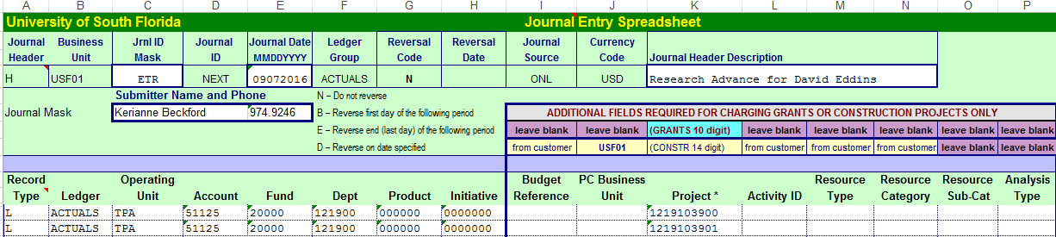

Some of the fields are masked in gray and not available for entry.

Begin by entering the “JRNL ID Mask”. A general practice is to use the mask “ETR” for non-payroll expenditure transfers.

Next enter a “journal date” in the format “MMDDYYYY”. Do not attempt to back date. If you were to enter a date from an accounting period that has already closed, the transaction will not post. A good general practice is to use the current date when this document is being prepared.

Next enter a complete and meaningful “Journal Header Description”. Include references that will fully support the document for both reconciliation and audit such as a voucher number, a PO number, a vendor name, vendor invoice number, etc.

Next, enter the chart field strings for both the debit and credit lines.

The “Record Type’ must always be “L”.
The Ledger must always be identified as “ACTUALS”.
A complete chart field string must be used including Operating Unit, GL Account, Fund,
Department ID, Product (even if default zeros), Initiative (even if default zeros),
and a Project ID if the line addresses a sponsored research grant. Do not enter a
PC Business Unit, Activity ID or Analysis Type as these are automated actions.
Only RFM and Physical Plant Construction use these fields for special reporting.

The credit amount line must include the exact chart field string that was used when the expense was originally posted to general ledger.

The debit amount line must include the correct full chart field string to be charged.

The next image is the remainder of the illustration form.

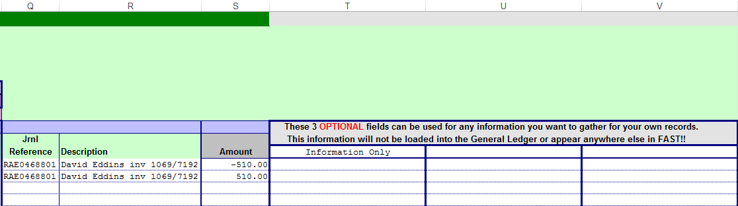

The “JRNL Reference” should be the orginal journal ID when the original expense was posted in general ledger.

The “Description” field provides opportunity for additional references that were not included in the Journal Header Description.

The amounts should express the credits and debits. Remember to credit (negative amount) the original charge that is being reversed and to debit (positive amount) the new chart field string to be charged.

Three additional optional description fields are provided if more references or notes are desired.

Note that the spreadsheet will indicate at the bottom of column S if the transaction is in balance for posting. Accounting transactions must net to a zero balance.

Interdepartmental Billing

The image below is a partial sample illustration of an interdepartmental billing by the Research Compliance auxiliary charging multiple sponsored research grants.

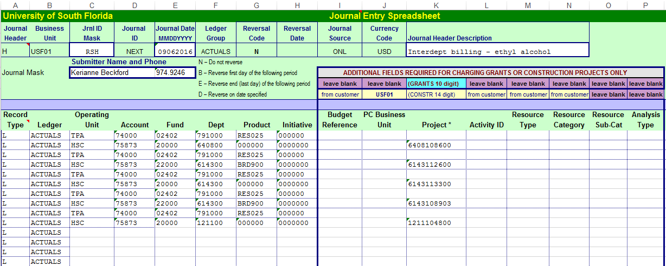

The “JRNL ID Mask” should reflect the auxiliary that is charging for the service and is recording revenue. Find a complete list of all journal masks on the UCO web site at http://www.usf.edu/business-finance/controller/accounting-reporting/gaforms.aspx . This illustration uses “RSH” “Research”.

Next enter a “journal date” in the format “MMDDYYYY”. Do not attempt to back date. If you were to enter a date from an accounting period that has already closed, the transaction will not post. A good general practice is to use the current date when this document is being prepared.

Next enter a complete and meaningful “Journal Header Description”. Include references that will fully support the document for both reconciliation and audit. Note this illustration identifies the product that was sold.

Next, enter the chart field strings for both the debit and credit lines.

The “Record Type’ must always be “L”.
The Ledger must always be identified as “ACTUALS”.
A complete chart field string must be used including Operating Unit, GL Account, Fund,
Department ID, Product (even if default zeros), Initiative (even if default zeros),
and a Project ID if the line addresses a sponsored research grant. Do not enter a
PC Business Unit, Activity ID or Analysis Type as these are automated actions.
Only RFM and Physical Plant Construction use these fields for special reporting.

Note that interdepartmental billing transactions use a special GL account group. The “7” in the first position indicates it is an interdepartmental transaction. A “4” in the second position indicates the transaction line is the revenue posting. A “5” in the second position indicates the transaction line is the expense posting.

Note that for interdepartmental billings, every transaction must use a GL account that begins with a “7” and only a “7”. This will ensure that the transaction will successfully meet combination edit rules.

The next image is the remainder of the illustration form.

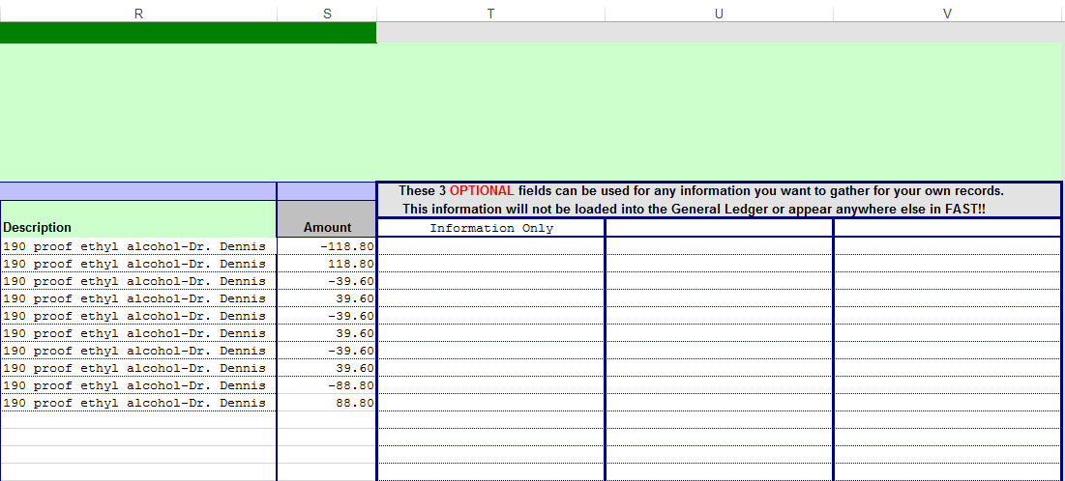

The “JRNL Reference” should be the orginal journal ID when the original expense was posted in general ledger if this is a correcting entry. The “JRNL Reference” should be blank if this is an original billing entry. The description in this illustration identifies what specific service was provided and the name of the PI (project investigator).

The “Description” field provides opportunity for additional references that were not included in the Journal Header Description.

The amounts should express the credits and debits. Remember to credit (negative amount) the revenue line and to debit (positive amount) the expense line.

Three additional optional description fields are provided if more references or notes are desired.

Note that the spreadsheet will indicate at the bottom of column S if the transaction is in balance for posting. Accounting transactions must net to a zero balance.

Submission of Request

Send journal entry requests to the following addresses for review and posting by General Accounting.

RNSexpt@usf.edu for expenditure transfers

RNSinterdept@usf.edu for cash transfers or interdepartmental billings

Journal entry requests for departmental state funds (fund 10000 or 10009) or for auxiliary funds (auxiliary funds begin with a “0”) need approval of either a requisition approver/manager or the accountable officer for the chart field. Journal entry requests that include a sponsored research project or initiative will be reviewed by RFM. Any central billing transaction that is to be submitted to the UCO for processing must be agreed to by both parties (one being charged and one receiving revenue). It is the responsibility of the department that is providing the chart field to be expensed, especially if it is project related, to ensure that the expense in question is allowable for the fund and/or project. Approvals for interdepartmental billings should be obtained prior to submitting any journal entries and documentation of approval should be maintained by the billing department. All interdepartmental journal entries submitted to Service Now must indicate the preparer and have the appropriate approval within the Service Now incident. If the interdepartmental journal entry is not properly approved it cannot be posted.
Your request will be logged in the UCO Service Now instance. A unique tracking number in the form UCOxxxxxxx will be assigned; you will receive automatic notification of receipt of your request and the tracking number. This tracking number will offer the opportunity for communication between you and General Accounting. Once the transaction has been posted in general ledger, you will receive notification of the action.

Remember to complete the justification page if the transaction involves a sponsored research grant. It is advised that you attach any and all supporting documentation to your email. Your attachments may be in the form of an email, a spreadsheet, a Word document, or a pdf.

Frequently Asked Questions

• How does a department get authorization to invoice customers for services?

You must first submit an EBA (Educational Business Activity) request. If the EBA is approved, you will be given a unique auxiliary fund ID in which you will conduct your business activity.

• Where is EBA information found?

Information about EBA and the EBA request form can be found on the UCO web site: www.usf.edu/business-finance/controller . Look under the Accounting and Reporting tab under Forms.

• How do I invoice other USF departments for services I sell them?

When one USF department provides a service for another USF department, the billing module is not used. You would bill for your services by creating an interdepartmental journal entry. Find the Journal Entry Spreadsheet on the UCO web site, www.usf.edu/business-finance/controller . Look under the Accounting and Reporting tab under Forms.

Resources/Contact Information

Office of the Controller
Phone: (813) 974-6061
Fax: (813) 974-4485
www.usf.edu/business-finance/controller

General Accounting
Fax: (813) 974-2622
http://www.usf.edu/business-finance/controller/accounting-reporting/index.aspx

Training and Resources
http://www.usf.edu/business-finance/controller/about/training.aspx

Business Processes
www.usf.edu/businessprocesses

