FAST Financials – Building a Private Query

This document is designed to provide basic knowledge for building your own private queries in FAST (PeopleSoft Financials 9.2). Query is a graphical tool that allows you to easily retrieve the specific data you want from FAST by specifying the records (tables), fields, and criteria to be applied to the search. Query results may then be viewed on screen, run to HTML, or saved as an Excel spreadsheet.

A large number of queries currently exist in FAST to help you manage your funds and transactions. Queries may be either private and connected to your FAST ID that only you may use, or public for any user to use. Most USF public queries are recognizable; they are named as U_xxxxxxx. A USF public query may be saved and renamed as a private query by any user.

There is a list of commonly used public queries on the Controller’s Office web site: www.usf.edu/business-finance/controller . Find the document under “About UCO/Library of Resources”.

A private query may also be copied from one user to any other FAST user. That FAST user may then modify the query to suit their needs or use it as is.

This document, as part of the introduction to queries, illustrates how to create a private query. No special FAST security access role is required. The basic USF_INQUIRY role should provide you the necessary access.

Contents

Exercise 1 Determine the purpose of the query Page 2

Exercise 2 Understanding tables Page 3

Exercise 3 Adding additional criteria Page 19

Exercise 4 Grouping of criteria Page 25

Exercise 5 Copy a public query as private Page 27

Exercise 6 Copy a private query to another user Page 30

Exercise 7 Viewing a list of your private queries Page 32

Index of Resources Page 35

Exercise 1: Determine the purpose of the query

To build an effective query, it is necessary to first define what results and what data is needed. Begin by defining how the query data will be used. What is the purpose of the analysis or the report? What date range of data is needed? What specific values are needed; for instance individual chart fields, dollar values, user IDs, dates, document references or descriptions.

Queries are based on data selected from tables of which there are many in FAST/PeopleSoft. It is often necessary to employ multiple tables to report the desired data and include all desired elements. For queries that include more than one table, often the tables must be joined.

The query results may be delivered in Excel format that facilitates editing, reformatting, and reconfiguration of the columns.

Before building a private query, it is best to identify whether a public query already exists that will deliver the data you need. All public queries are available to all FAST users. Remember that public queries can be altered to suit your immediate, specific needs and deliver the report you need. But also remember that once you navigate away from the query menu, the query reverts to its original condition; you cannot make any permanent changes to the query. But if you alter and run a public query, you can save it as a private query with a customized name. Then you have a private query for future use and the original public query remains intact.

 A few helpful tips
√ Before building a private query, look for an existing public query that either meets your needs or can be altered to meet your needs.
√ Carefully analyze what specific results you need to report and how the results will be used.

√ Remember that a public query can be saved as a private query for future use.
Basic Steps for Building a Query
√ Navigate to Create a New Query
√ Add one or more records as needed
√ Add criteria as needed
√ Save and name the query

Exercise 2: Understanding tables (Records)

Step 1 Navigate to Query Manager

Click: Reporting Tools
Query
Query Manager

Step 2 Click “Create New Query”

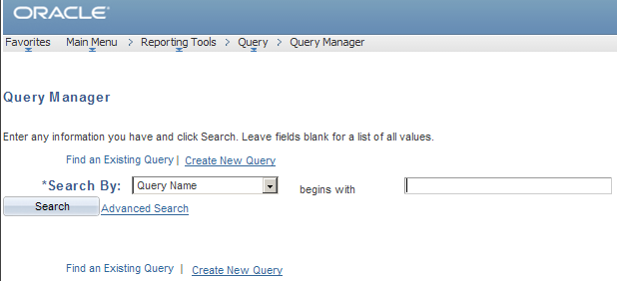

The following illustration will appear.

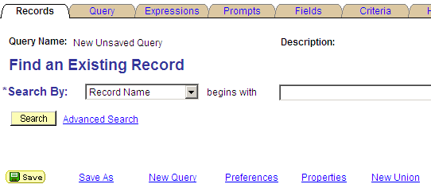

Step 3 In FAST/PeopleSoft, the “Record” refers to the table that holds the data for which you are searching. Enter the name or the first part of the name of the record. If you do not know the exact table name (Record) use “Advanced Search” to find the table using a keyword and use the operator “contains”.

HINT: the result we want for this illustration is a list of all active GL account codes. The account code is one of the basic chart field values used to compose our accounting entries. When searching for the right record (table) search for the word “account”. The search will present a list of table names that contain the word account.

In PeopleSoft, chart fields are recorded in the General Ledger. There is a record for each individual chart field (Operating Unit, Fund ID, GL Account Code, Department, Product, and Initiative).

Illustration of navigation if the exact record name is known:

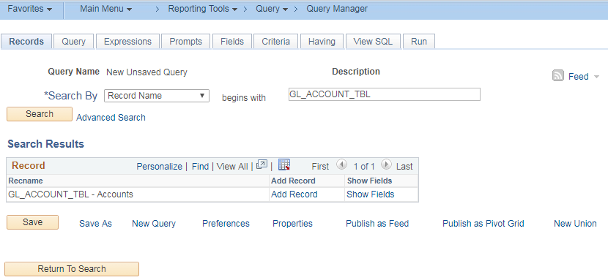

Illustration of navigation using “Advanced Search” when the complete, exact record name is not known:

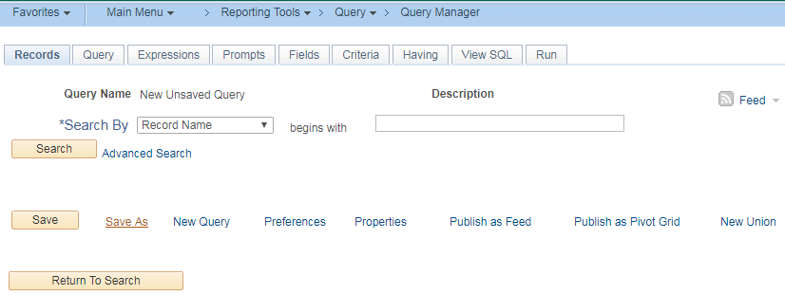

Then to conduct the search enter part of the record name; remember to search by including the operator “contains”. You could also search by Description “contains” a key word.

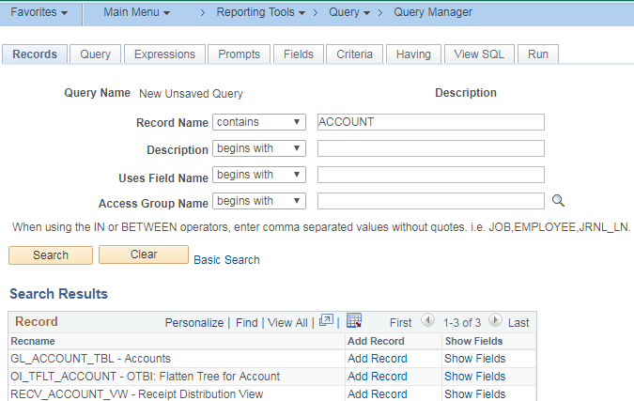

Whether you search by the actual record name or by using the “Advanced Search” function, when the search results are displayed, click “Show Fields” to confirm that you are selecting the record that you do need. For GL_ACCOUNT_TBL “Show Fields” reveals 35 fields:

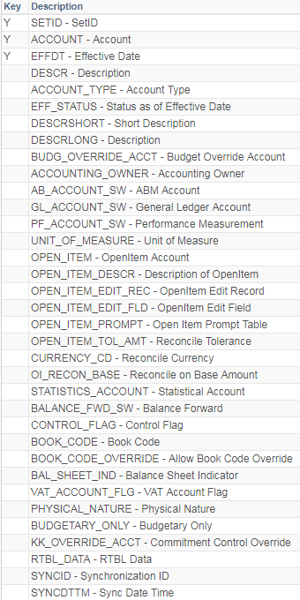

Step 4 Your search will produce a list of tables (Records) containing the word “account”. Select the record GL_ACCOUNT_TBL by clicking the button.

The following screen will display with a message box. The message indicates that an effective date criteria will be automatically added to the query. Click the OK button on the message.

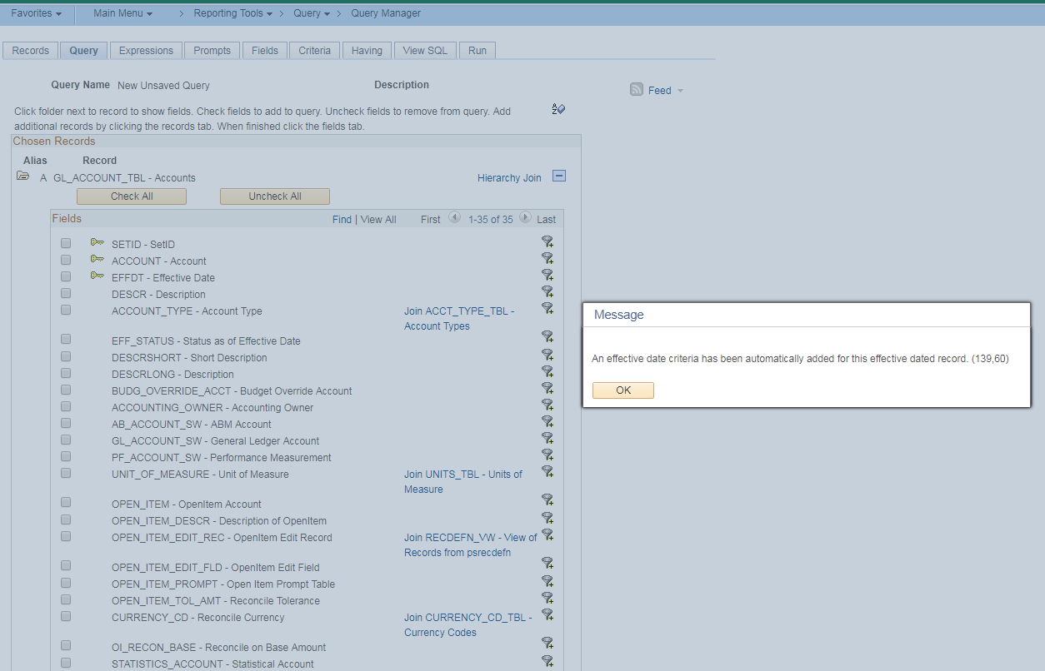

In this illustration, a total of 35 fields are returned for this record. Some tables will display in chunks of 100 if more than 100 fields are returned. Look at the dark blue line to identify how many items are delivered.

Step 5 The Query tab will appear. You will see the table (record) named followed by a list of the fields the record (table) includes. Most often you will not need and will not want all of the fields included in the query results, so on the Query page check the boxes for all the fields that you do want displayed when the query is run. At a minimum, all fields with a key symbol should be checked. Checking unneeded fields may result in a spreadsheet that is cumbersome to view and use. But remember, you can always modify the query by adding (checking) or removing (un-checking) fields after the query has been created and saved.

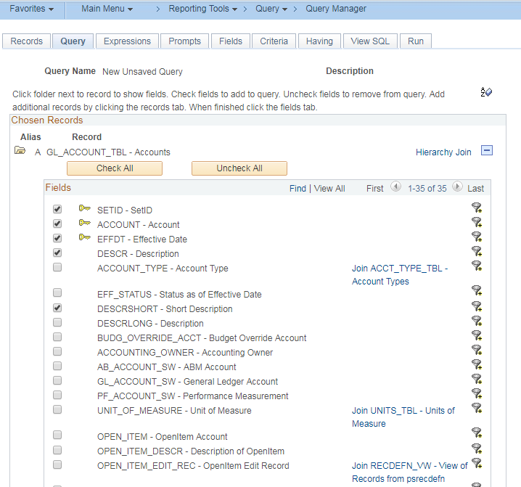

You can also confirm the fields that you have selected from a record by navigation (clicking) the “Fields” tab and viewing the results.

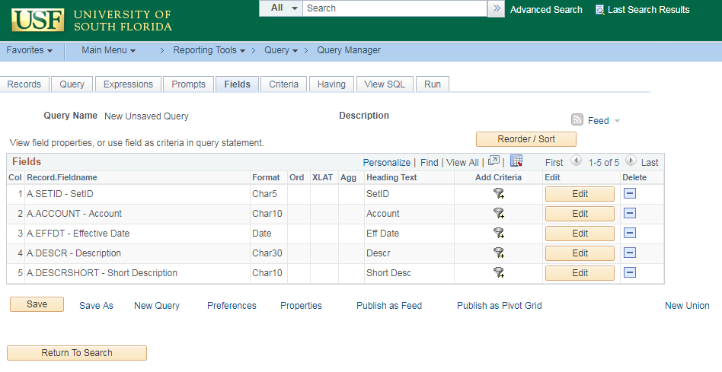

You also have the option to modify what is displayed as the headings at the top of your columns. Select a field to modify, then click the button.

This illustration uses the “Account” field.

In the Edit Field Properties box that appears, change the “Heading Text” to another value, in this illustration the Heading Text is changed to GL Account. Click the button to save your change.
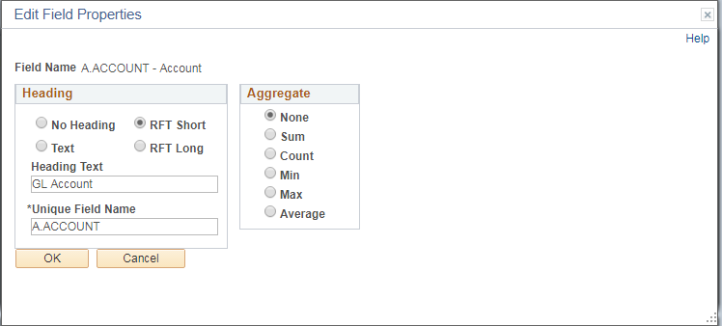

The new heading text will appear.

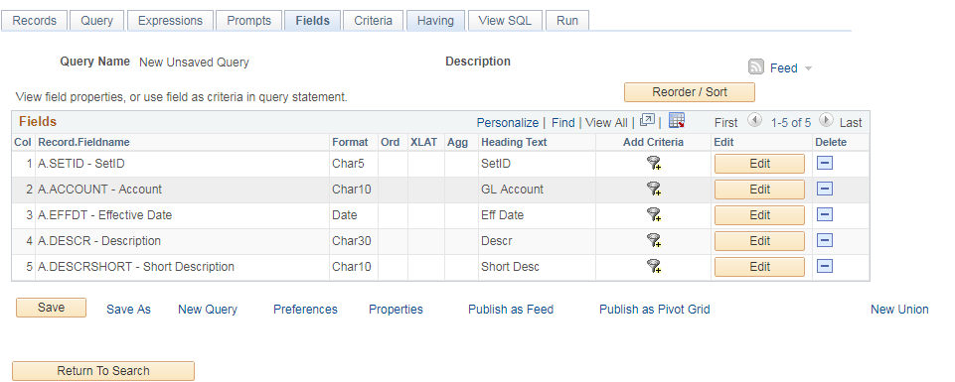

Step 6 If desired you can also change the order in which the columns are displayed. Under the “Fields” tab, click the to see how the columns are currently ordered.

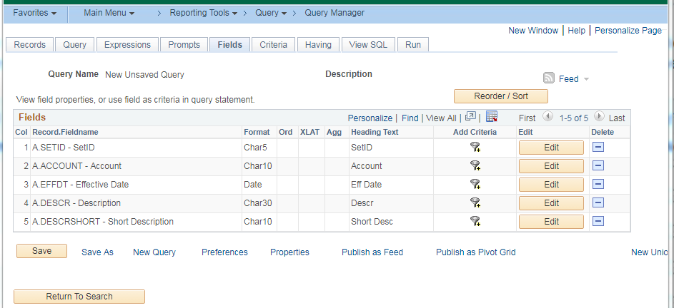

The “Edit Field Ordering” page will appear.

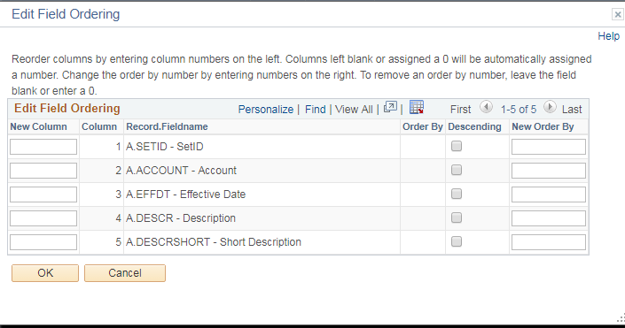

In the “New Column” fields, enter numerically the new order of the columns as illustrated below. Then
click the button to save your changes.

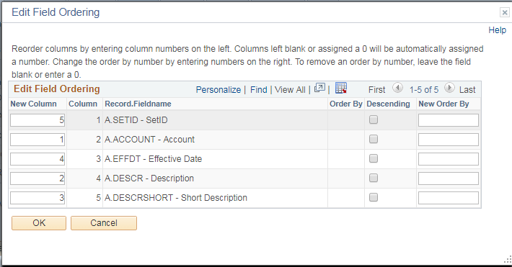

The new order of columns will appear.

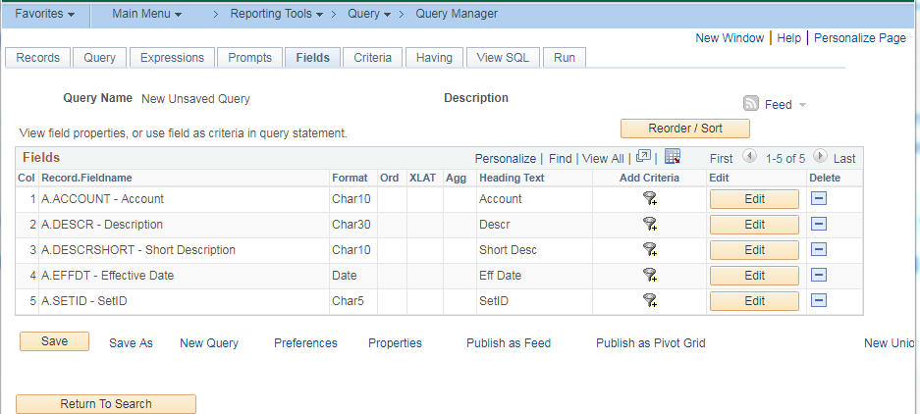

You can also change the sort order of your output results. Under the “Fields” tab, click the to see how the columns are currently ordered.

The “Edit Field Ordering” page will appear.

In the “New Order By” column, you can enter the new sort order. Enter numeric values for the desired
Sort order. To remove a column from the sort order, enter a zero in that field. Click button.

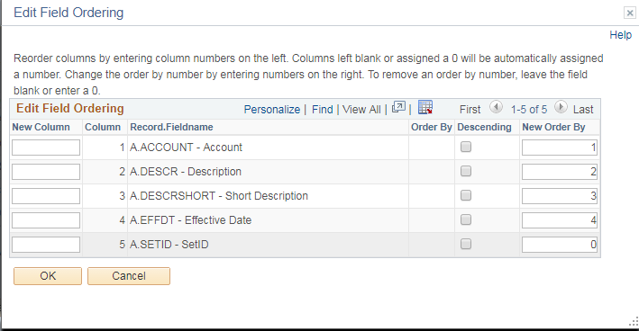

Step 7 Next click the Criteria tab; it will show that criteria has been added for the effective date. Additional criteria are needed to select the correct data for the report. Consider the report that is desired; a report of all active GL account codes. The two criteria that need to be added are 1) the status of “active” and 2) the desired Set ID (chart fields are created under a specific Set ID). At USF the only valid SetID is “USFSI”. To add additional criteria, click the button.

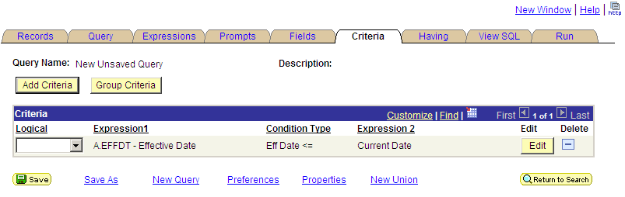

Step 8 You will see the criteria setup page (illustration below).

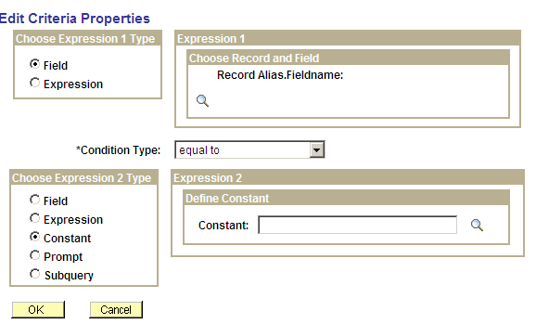

Step 9 Two default values will appear; the “Field” button will be checked and the “Constant” button will also be checked. Do not change either.

Next, choose the first Record Alias Field Name; this is simply one of the fields that you checked on the table (record) page in step 5. Click the search button (spy glass) to view a list of Record Alias Names. Let’s first establish the correct Set ID by clicking the Set ID hyperlink.

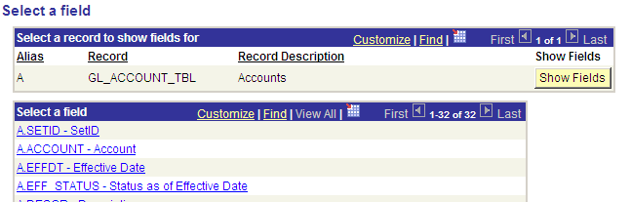

You will then be returned to the Edit Criteria Properties page. Next enter the SetID “USFSI” as the constant. Then click .

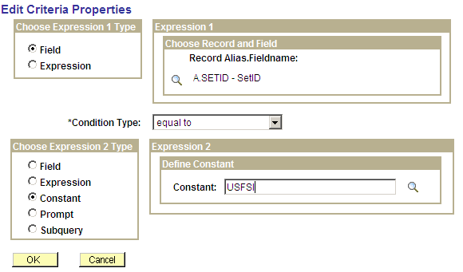

Step 10 Add the status “A” as another criteria repeating step 9 above. Remember that you can type the specific constant value or search for it using the button.

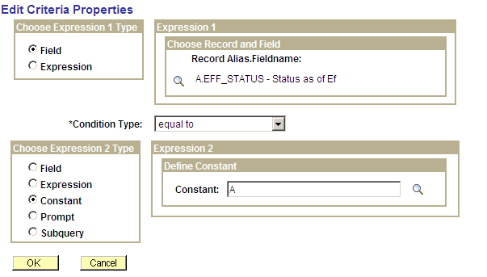
Step 11 You will now have three criteria established as illustrated below.

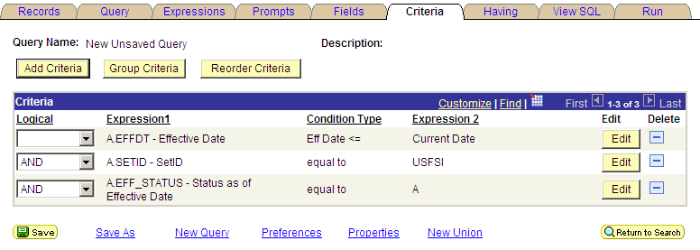

Step 12 It is now a good time to name and save the query. Click the button. Then create the query name and description (required fields). You may also enter a query definition but this is optional. Then click . The query name should begin with “U_” and should then include an abbreviated but clear name that other users will recognize. Query names cannot include any spaces but may contain an underscore to separate words as illustrated below.

When a query is initially built, it will be a private query. But you may want to promote it to public status in the future or share the query with others. To help other users search for and identify the query, it is helpful to use recognizable words or phrases in the query name.

In the illustration below, the word “accountcode” is used. It could also have been named U_ACCOUNT_CODE_LIST or U_GL _ACCOUNT_CODE_LIST. There is flexibility in naming queries but it is best to use phrases or words that others will recognize.

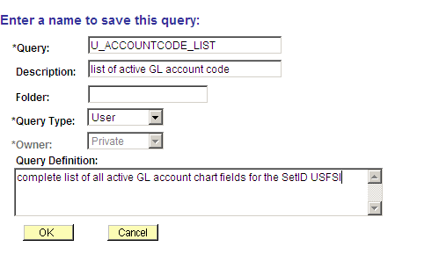

Step 13 To run the query, click the Run tab on the far right. The results will be displayed with an option to . You may then save the Excel spreadsheet and modify or re-arrange it as needed or combine it with another spreadsheet.

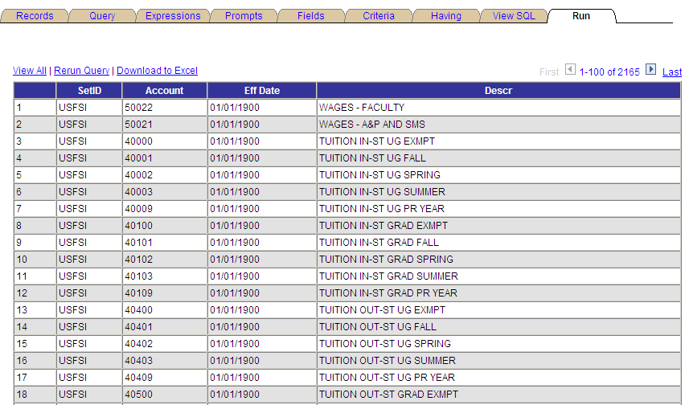

A few helpful tips
√ The results you generate with a query will depend on the tables that are used in the query. Choose the table carefully. If you are unsure, consult one of the resources at the end of this document.
√ Remember to include all of the fields that you want displayed by checking the appropriate boxes on the table information displayed on the Query tab.
√ You may run a query to view on screen or you may download it to an Excel spreadsheet.
√ Remember to name your query carefully; it should intuitively describe the purpose. It must also begin with U_ to identify it as a USF developed query.
√ Remember that when queries are initially written, they are private and usable only by the person who created them. You may transfer the query to another user; when you do that the other user will have access to a copy of the query which is still private to them.
√ Public queries may be viewed by any user.
√ Any user may save a copy of a public query as a private query. Then you can modify the private copy to suit your specific needs.
√ Once you write a private query, you may update it at any time by adding or deleting records, adding or deleting fields, or adding/modifying/deleting any criteria.

Exercise 3: Adding Additional Criteria to Limit the Results: You may need to add or remove criteria from a private query on occasion. This can be done easily. For illustration, let’s use the query we created in Exercise 2 above (named U_ACCOUNTCODE_LIST).

Step 1 To find an existing query, use the left-hand navigation menu. Select “Reporting Tools” and drill down through the “Query” folder to the “Query Manager” hyperlink. Click the “Query Manager” hyperlink.

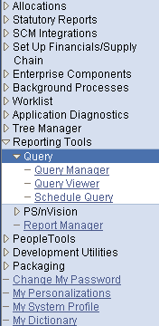

Step 2 If you know the full exact name of the query, enter that name in the search box and click the button. In this illustration we will look for U_CF_ACCOUNT.

If you do not know the full exact query name, remember that you can use the “Advanced Search” feature to find a query by using a shred of the name. See tips for this search method in Exercise 1, steps 3 and 4.

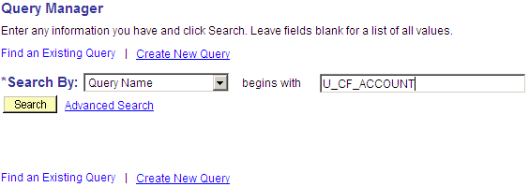

Step 3 When the query name appears, click the button.

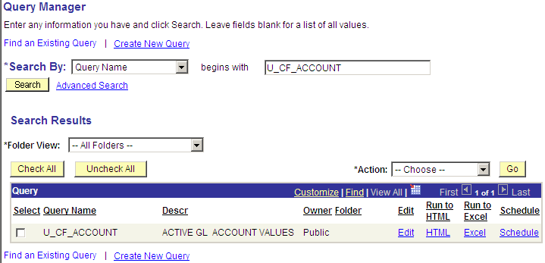

Step 4 Once you have opened the query, click the “Criteria” tab. You will see all current criteria displayed. In this illustration, there are 3 criteria currently.

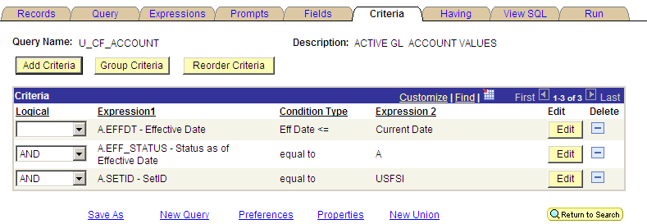

Step 5 To add additional criteria, click the button. You will see the criteria setup page (illustration below).

Step 6 Setup a new criteria to add to the existing criteria. Remember that criteria are a filter to customize the results of the criteria. For this illustration, build criteria that will result in a report of only those GL account codes that begin with a “1”. Note the diagram below to understand how to use condition types.

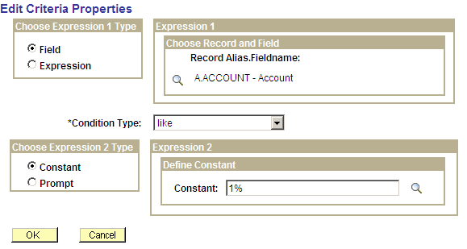

Condition Type Options

Between | The value in the selected record field falls between two comparison values. The range is inclusive.
Equal To | The value in the selected record field exactly matches the comparison value.
Exists | This operator is different from the others, in that it does not compare a record field to the comparison value. The comparison value is a subquery. If the subquery returns any data, PeopleSoft Query returns the corresponding row.
Greater Than | The value in the record field is greater than the comparison value.
In List | The value in the selected record field matches one of the comparison values in a list.
Is Null | The selected record field does not have a value in it. You do not specify a comparison value for this operator. Key fields, required fields, character fields, and numeric fields do not allow null values.
Less Than | The value in the record field is less than the comparison value.
Like | The value in the selected field matches a specified string pattern. The comparison value may be a string that contains wildcard characters. The wild-card characters that PeopleSoft Query recognizes are % and _. % matches any string of zero or more characters. For example, C% matches any string starting with C, including C alone.  % matches any string of zero or more characters. For example, C% matches any string starting with C, including C alone.

Step 7 We now have a query with 4 criteria.

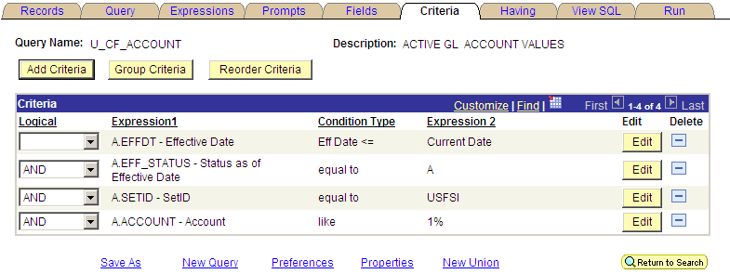

Step 8 When the query is run, the results will report only GL account codes that begin with a “1”, a total of 135 codes.

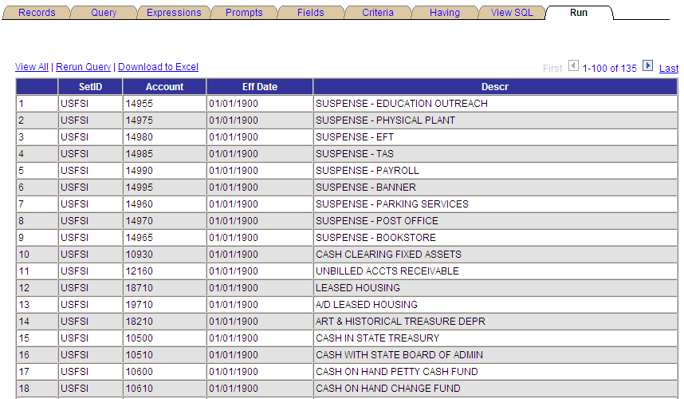

Step 9 Removing criteria is even easier. Navigate to the Criteria tab (as in step 5 above).

Step 10 To remove any criteria, just click the button to the right of the specific criteria and it will instantly disappear.

Step 11 Using Boolean operands in expressions

When you specify two or more selection criteria in a query, you must include in the web query an
instruction for how to coordinate the different criteria. When your query includes multiple criteria,
link them using “AND”, “AND NOT”, “OR”, or “OR NOT”. When you link two criteria with “AND”,
a row must meet the first and the second criterion for the query to return the value. When you link
two criteria with “OR”, a row must meet either the first criterion or the second criterion, but not
necessarily both.

By default, the query tool assumes that you want rows that meet all of the criteria that you specify.
When you add a new criterion, the default will display as “AND”. To change the command, click the
drop-down box and select the desired operand.

A few helpful tips
√ An alternative way to add criteria is to click a funnel icon on the Query page.
√ The funnel icon also appears on the Fields page.
√ Build your criteria the same way as in the exercise above.
√ Criteria may be edited, added or removed at any time.
Exercise 4: Grouping of Criteria: When your query includes multiple criteria, the query instructions check the criteria according to the rules of logic: it evaluates criteria that are linked by “ANDs” before those that are linked by “ORs”. When all criteria are linked by “ANDs”, this order always returns the correct results. When you include “ORs”, however, this is not always what you want.
For example in the USF public query U_GM_FIND_MY_GFA, a query that identifies the grant financial management team for a particular sponsored project, for some of the fields included (Project ID, Department, and Support Team), effective date must be considered. It is necessary to group the criteria to ensure that the correct results are delivered. Without criteria grouping, you could end up with excessive, unnecessary data being returned.
Notice below the open and close parentheses in the Expression columns indicate grouping.
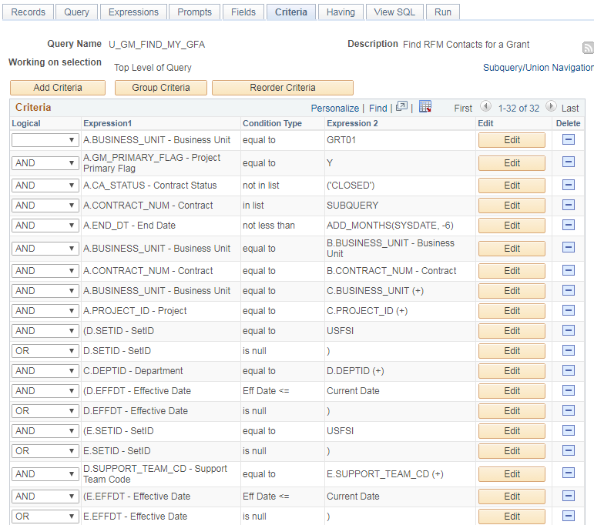
The query will evaluate the criteria inside the parentheses before the criteria outside the parentheses.
To group criteria:
Click the Group Criteria button on the criteria page. The Edit Criteria Grouping page appears.
Use the Edit boxes to enter open and close parentheses for the criteria needed.
Click the button to save your changes.
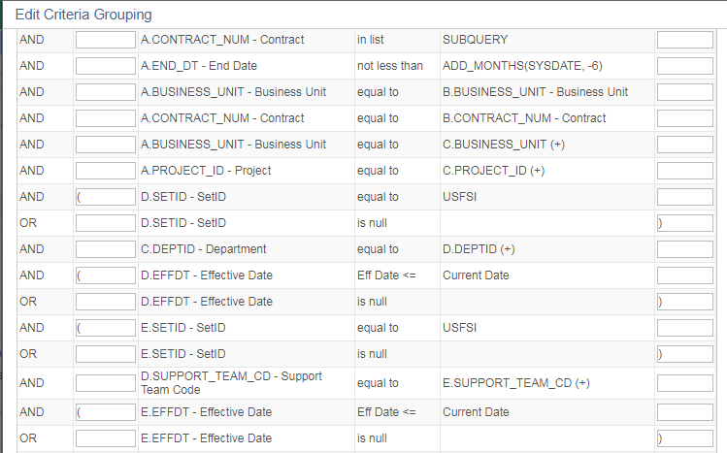

Exercise 5: Copying a Public Query as a Private Query: A public query may be copied as a private query which you can then modify to suit your needs. But be careful. Before making any changes examine the query carefully to understand how it was designed and make sure you have sufficient knowledge to modify it.

Step 1 Navigate in FAST through: Reporting Tools - Query - Query Manager.

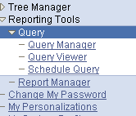

Step 2 If you know the full exact name of the query, enter that name in the search box and click the button.

If you do not know the full exact query name, remember that you can use the “Advanced Search” feature to find a query by using a shred of the name. See tips for this search method in Exercise 1, steps 3 and 4.

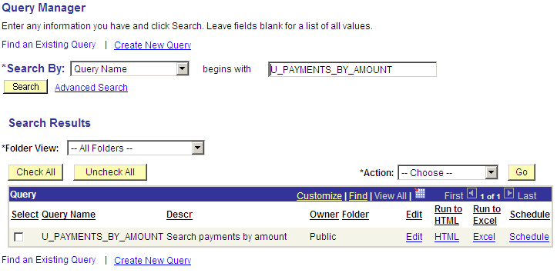

Step 3 Click the “Edit” button to call up the query.

Step 4 Click the “Save As” button; then enter the new name for the query. Then click the “OK” button.

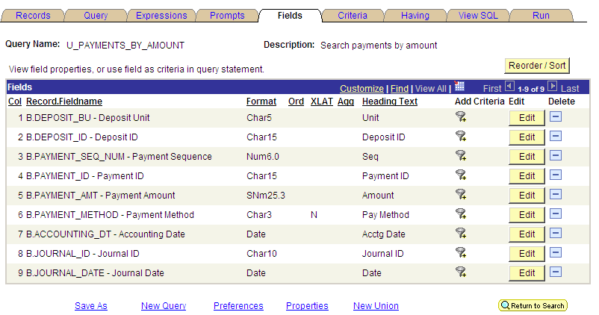

Type a new name for the query (in this illustration we added ALT to the name) and click the “OK” button. A new copy of the query is created using the new name; it will be a private query linked to your FAST user ID.

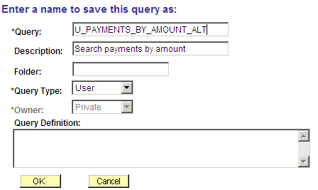

Exercise 6: Copying a Private Query to Another User: If you want to share a private query with another user or if another user wants to share one with you, the query can be made public or can be transferred from one user to another. Queries can only be shared with someone who has a valid FAST ID. It is simpler than it sounds.

Step 1 Navigate in FAST through: Reporting Tools - Query - Query Manager.

Step 2 If you know the full exact name of the query, enter that name in the search box and click the button.

If you do not know the full exact query name, remember that you can use the “Advanced Search” feature to find a query by using a shred of the name. See tips for this search method in Exercise 1, steps 3 and 4.

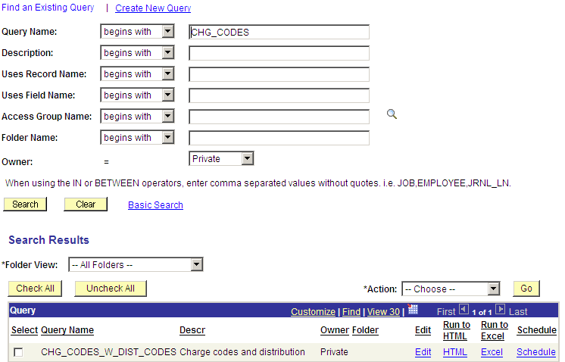

Step 3 Check the select box to the left of the query name that you wish to share with another user. You must check the select box even if only one query name appears as in this illustration.

Then select the “Copy to User” option from the “Action” box.

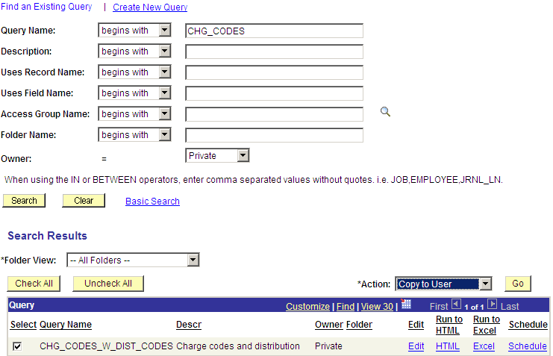

Step 4 Click the “Go” button, then enter the FAST user ID of the person to whom you wish to copy the query.

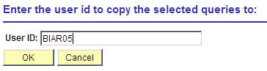 Then click the “OK” button.

You will then be presented with a confirmation message that the query has been copied.

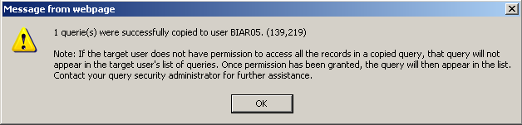

Exercise 7: Viewing a list of your private queries: You may easily view a list of your own private queries. You do not need to remember the exact names of your queries.

Step 1 Navigate in FAST through: Reporting Tools - Query - Query Manager.

Step 2 Search using the Advanced Search method. Click Advanced Search.

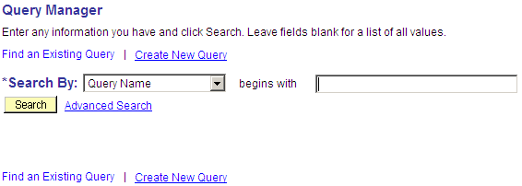

Step 3 From the drop-down menu in the “Owner” field, select the “private” option. Click “Search”.

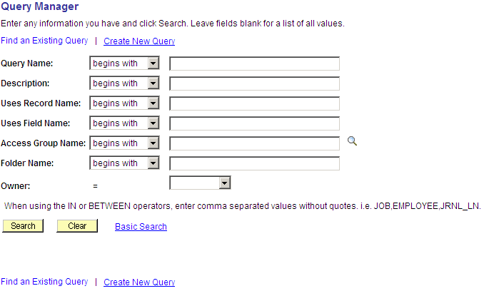

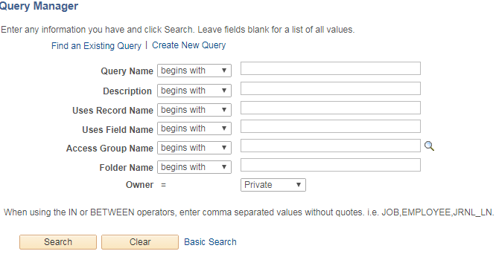

Step 4 You will then see a list of your private queries which you may run or edit as needed.

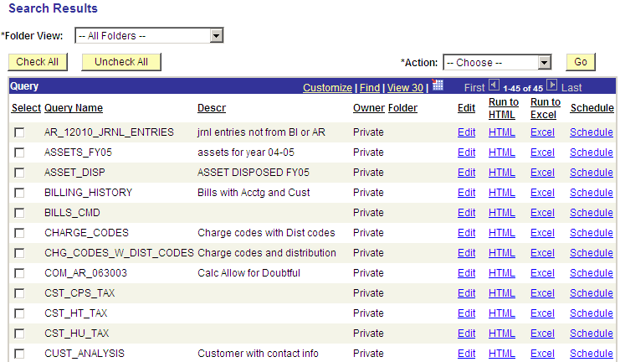

A Recap

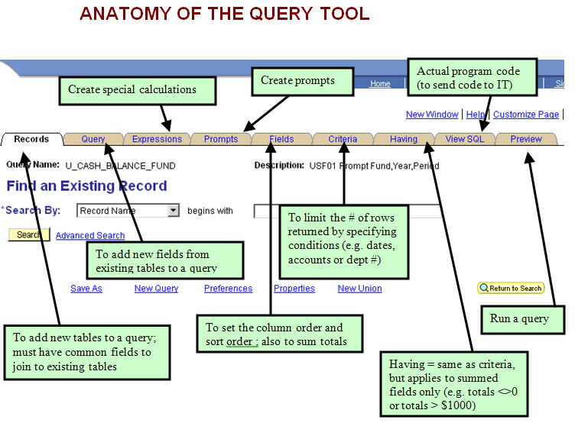

Great Resources Available to All

- Find a library of training material on the UCO web site

Business practice
Accounting
Cash controls
PCI compliance
Finance Mart
Module training
Billing and accounts receivable
Purchasing
Pcard
Travel
Assets

http://www.usf.edu/business-finance/controller/about/training.aspx

