Exploring General Ledger
And Commitment Control
In FAST

Finance and Account



Information compiled and prepared by:

Controller's Office, University of South Florida
www.usf.edu/business-finance/controller
Last update: July 1, 2020

Contents – Creating Journal Entries for Posting in FAST

Requirements |  | 2
Overview |  | 2
Creating an Inquiry Name |  | 2
Searching GL with chart field values |  | 4
Drilling Down to Details of Other Modules |  | 84
Searching GL with a journal ID |  | 13
Exploring Commitment Control |  | 16
Frequently Asked Questions |  | 21
Resources/Contact Information |  | 217

Requirements

To fully benefit from exploring the general ledger and related pages, the user should hold the Inquiry security role in FAST.

Overview

The general ledger (GL) module is the source for all financial reporting. It receives information in the form of journal entries from all of the FAST/PeopleSoft modules as well as summarized information from USF including GEMS payroll data, OASIS student information, Physical Plant billings, and TAS (IT telephone) billings. Additionally journal entries may be created using the journal entry template for expenditure transfers and interdepartmental billings.

You may search the GL in two ways; either by chart fields or by journal IDs. Both methods will lead to the same results.

When searching GL, it is necessary to have an “Inquiry name”. This is not your FAST user ID. It is a name that you create for the criteria that you use to search GL. It is unique to you. It will save the criteria for the next time you conduct a GL search. An example of an inquiry name could be as simple as “GL”. Note that the inquiry name cannot have any spaces. Keep it simple and make it something you will recognize.

From the GL, if the transaction was created in another module of FAST, you can drill to other modules for more information.

Creating an Inquiry Name

Many reports in FAST require an inquiry name be created. This is a one-time action to create an inquiry name that is unique to your FAST ID. Once setup, simply look for this inquiry name when prompted to conduct GL searches.

Navigate: General Ledger/Review Financial Information/Ledger. You will see this page appear, defaulting to the “Find an Existing Value” tab.

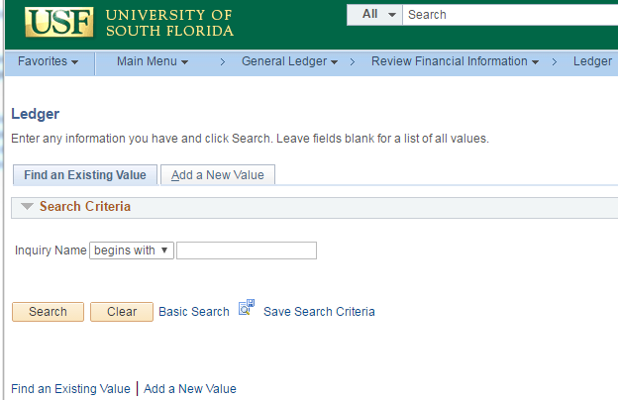

Click the “Add a New Value” tab. Then enter your desired inquiry name. Then click the button.

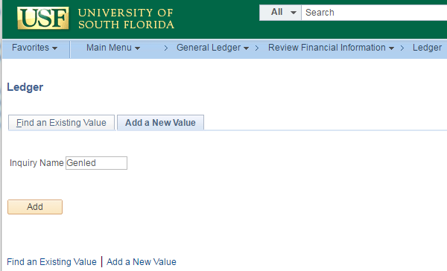

You will see this page appear. Click . As you add information to the available fields, additional fields will appear. Build your seach using the instructions below.

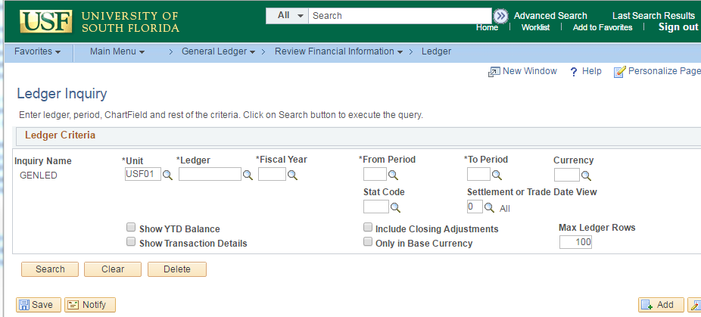

Searching GL with Chart Field Values

Navigate: General Ledger/Review Financial Information/Ledger. You will see this page appear, defaulting to the “Find an Existing Value” tab. Click the button. You will either advance to the Ledger Inquiry page or be presented with a choice of an inquiry name (if you have more than one inquiry name). If a list of names is presented, click the desired inquiry name to view the Ledger Inquiry page (see image below).

Key points to build a successful search.

The Unit must be “USF01”
Select the correct Ledger
Select the correct Fiscal Year
Select the correct periods
Check “Show YTD Balance”, “Include Closing Adjustments”, and “Include Period 998”
Enter a large number for “Max Ledger Rows”
Check all of the necessary “Sum By” boxes

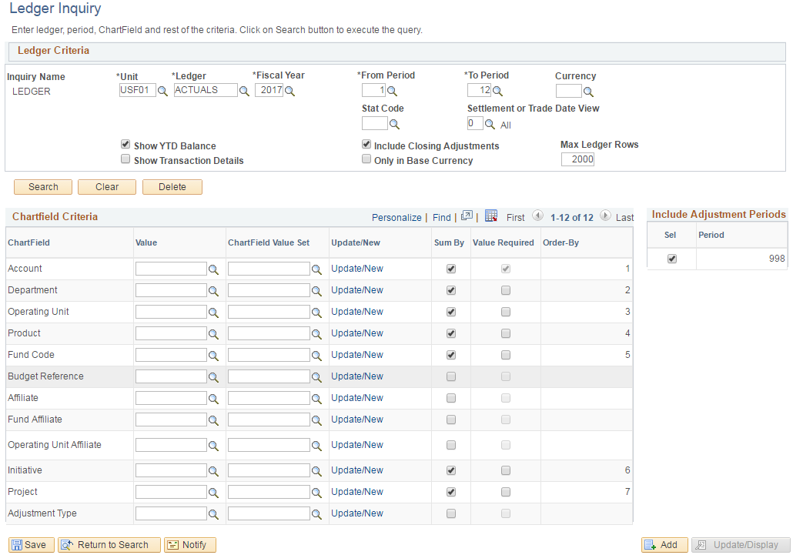

Note the illustration above.

The “Unit” must always be “USF01”.

The “Ledger” must always be “Actuals”. Type this or search from the list.

Select the desired “Fiscal Year”. Search from the list.

Select the desired “From Period” and “To Period”. If searching for a single period (month)
enter the same period number in both fields. Otherwise, enter a range of periods. Note
that accounting periods are named by a number (July is period 1, August is period 2, and
June is period 3) for example. A safe practice for producing year-to-date information is
to select period 1 through period 12, no matter what the current month is.

Check the “Show YTD Balance” box if searching for more than a one month period.

Check the “Include Closing Adjustments” box if searching for more than a one month
period.

Check the “Include Adjustment Periods” if searching for more than a one month period.

Note; if searching for a single month of data, do not check these three boxes.

Enter a large number in the “Max Ledger Rows” field to ensure all relevant data is
delivered by your search.

Check the “Sum By” boxes for all seven of the primary chart fields. This is a very
important step to ensure that all relevant data is delivered from the search.

Check the “Sum By” boxes for”

Account
Department
Operating Unit
Product
Fund Code
Initiative
Project

Next enter the desired chart fields to search.



Use a minimal search with chart fields.

If searching for an auxiliary fund, use only the Fund ID
If searching for a department, use only Fund ID and Department ID
If searching for a sponsored project, use only the Project ID to report
all activity including any cost share data
For sponsored projects you may exclude the cost share data by searching
with the Project ID and the grant Fund ID
If searching for an RIA fund, use only the Initiative ID

Additional tips:

You may further enhance your search by using the “%” sign as a wild card.

For instance a Fund ID value of “07%” will report all USFSP auxiliaries; a
Department ID of “1201%” will report all departments in the College of Arts and
Sciences Dean’s Office. Searching for Account “44%” will report only commercial
auxiliary revenue.

The following image is an illustration of a search for auxiliary fund 07001.

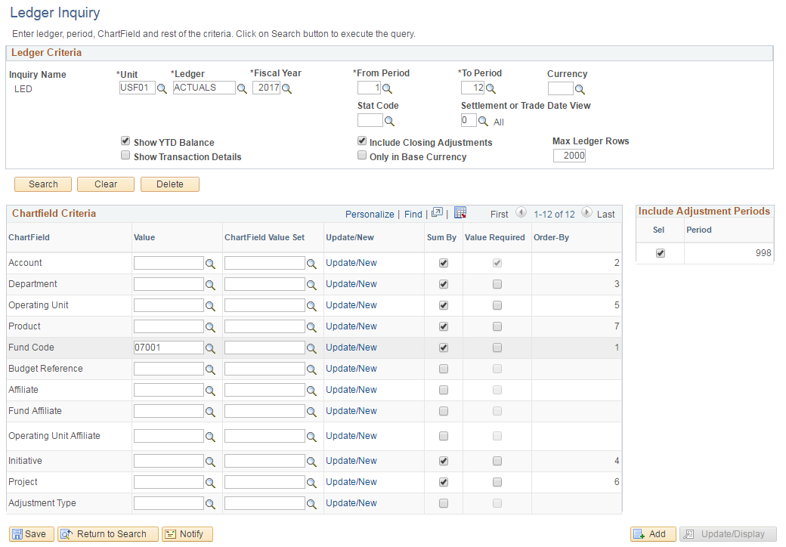

This search will produce all accounting transactions for the auxiliary fund 07001 regardless what other chart fields are used for the year-to-date period of July 1, 2016 through the current date.

This search could be refined to report only cash transactions by including an Account value of “10%”.

This search could be refined to report only revenue transactions by using an Account value of “44%”.

When reconciling monthly transactions, it is beneficial to restrict the report to only one month and not include year-to-date information.

The following is an illustration of a search for auxiliary 07001 for the single month of July 2016. Note that “From Period” and “To Period” are the same; period 1 for July.

Also note that the “Show YTD Balance”, “Include Closing Adjustments”, and “Include Adjustment Periods” boxes are unchecked to allow the report to run correctly.

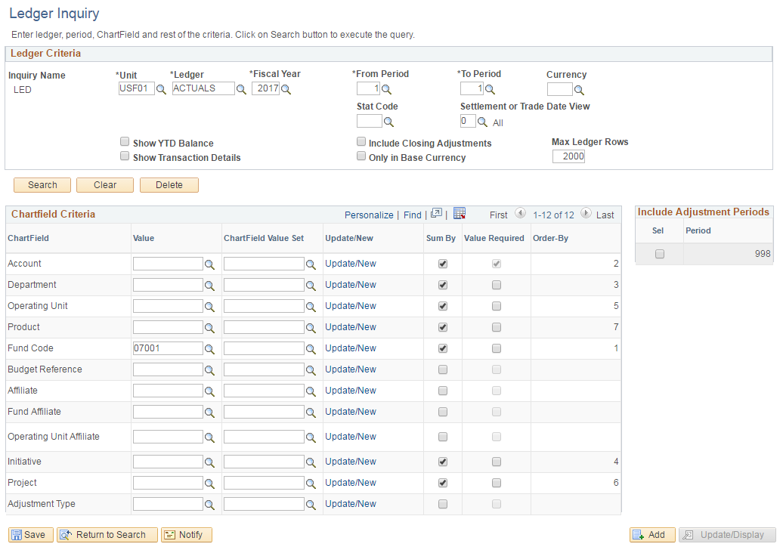

This search will deliver only accounting lines from the month of July with no balance forward entries. The accounting lines reported are based on the posting date in general ledger.

Drilling Down to Details of Other Modules

The initial report of results from the search above will deliver a summarization of data based first on the chart field(s) selected, then by accounting period.

It is then necessary to continue the search for more detailed information.

Executing the search above will progress as follows:

Summarized activity based on chart fields, then accounting periods appears first.
Followed by a list of all journals posted to a specific chart field string.
Followed by a list of all vouchers included in the journals.
Vouchers may be opened to review all contents (vendor information, invoice image, etc.)

The initial results (Ledger Summary) from the search illustrated above will appear as:

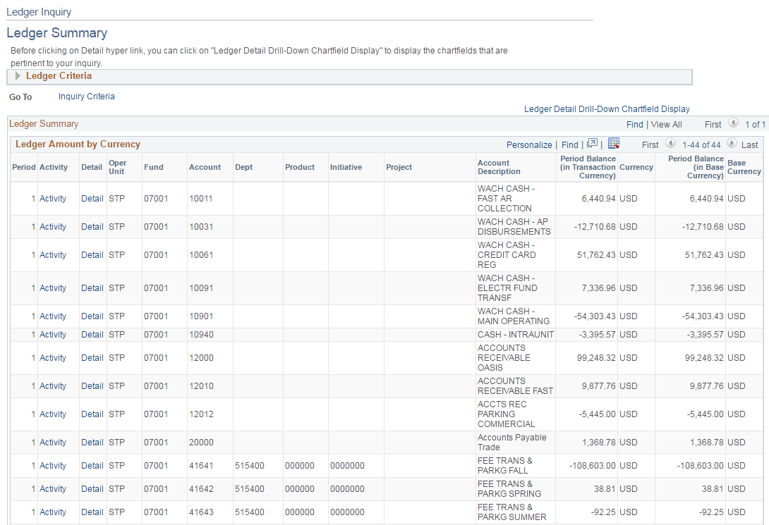

Click the “Activity” button for a desired chart field string. In this illustration below, the “Activity” button for the chart field string STP 07001 52543 515400 000000 0000000 was selected.

The activity revealed is two journals; the first posted on July 19, 2016 and the second posted on July 25, 2016.

Note the journal IDs. Both show a journal mask of “APA” indicating an accounts payable accrual action. This mask indicates the journal includes accounting entries for posting a debit to expense to the buying auxiliary and a credit to accounts payable as the vendor has not yet been paid.

Find a list of journal masks on the UCO web site at http://www.usf.edu/business-finance/controller/accounting-reporting/gaforms.aspx.

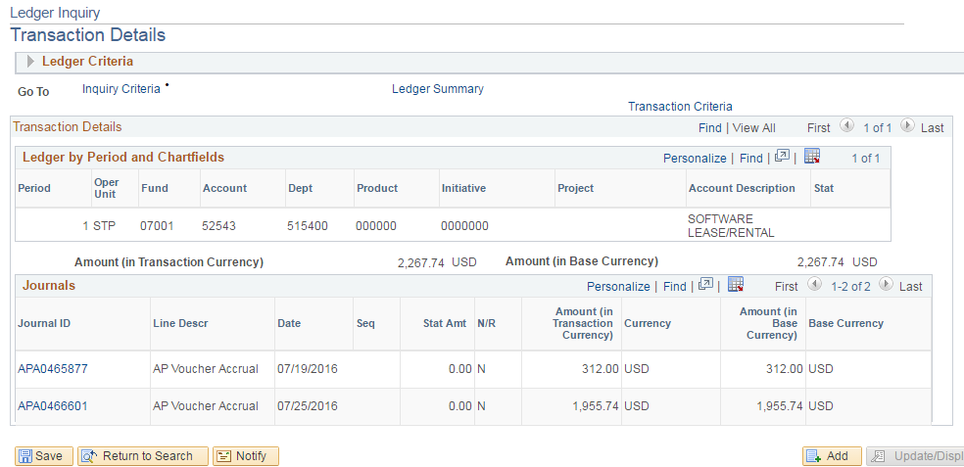

To open the journal to view all vouchers included in the journal, click the desired Journal ID. For illustration, the journal ID APA0466601 was selected revealing the Journal Inquiry Details page.

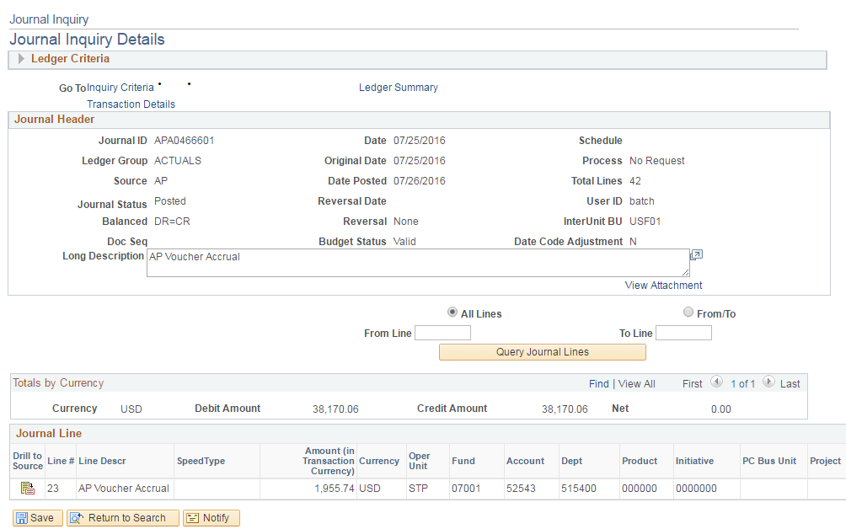

Next click the 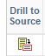 button to advance to a page focusing on the single voucher 01073099 in the amount $600.00.

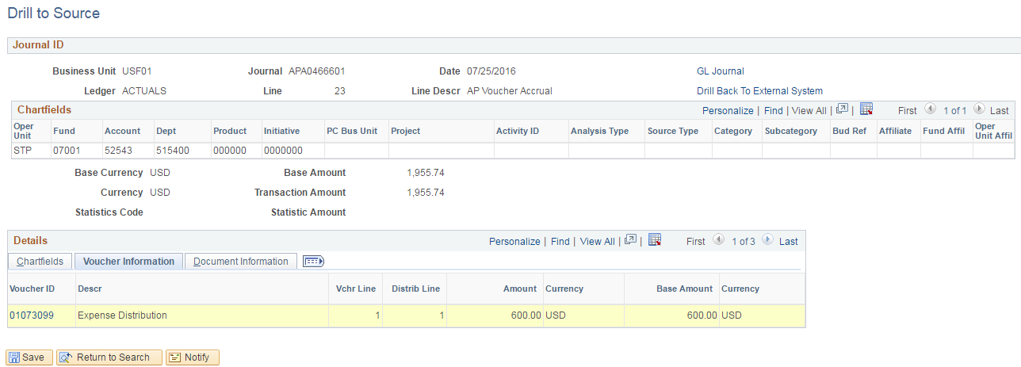

Click that Voucher ID number to advance to more information about the contents of the voucher. You will see illustrated the Voucher ID, the (vendor) Invoice Number, the (vendor) Supplier ID, the (vendor) Supplier Name, and accounting line detail.

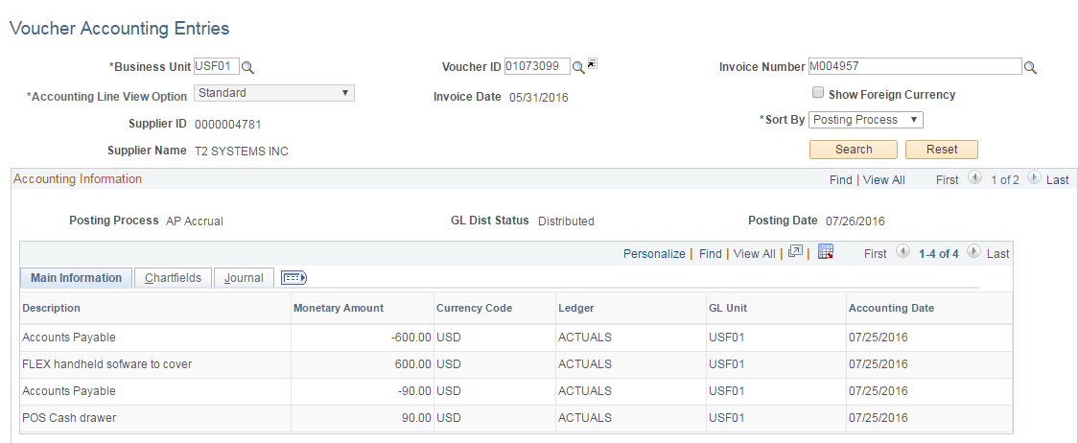

Using the Voucher ID, you can now locate the full voucher within the Accounts Payable module.

Copy the Voucher ID; in this illustration the voucher ID is 01073099.

Navigate: Accounts Payable/Review Accounts Payable Info/Vouchers/Voucher to reveal the Voucher Inquiry page.
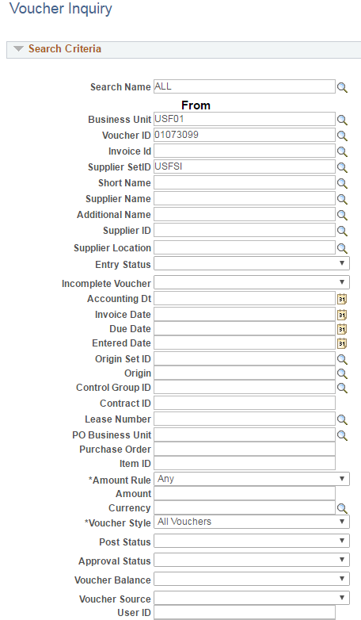

First ensure that the Business Unit is “USF01”. Then enter the Voucher ID. Then click the button at the bottom left corner of the page.

The Voucher Inquiry Results will display at the bottom of the page as in this illustration.

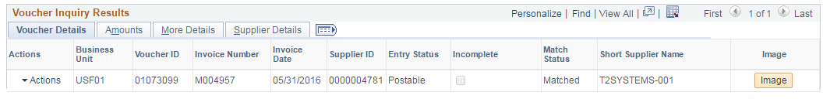

Searching GL with a Journal ID

When the clue available is a journal ID and no chart fields are known, search GL by the journal ID.

Understand that a journal may contain hundreds of accounting lines relating to multiple departments and chart field strings. Searching GL by journal entry will reveal the entire contents of the journal but there are ways to filter and/or sort the data to find the accounting lines relevant to your needs.

This GL search also requires an Inquiry Name. Setup an inquiry name as described on page 2 of this document but use this navigation:

Navigate: General Ledger/Review Financial Information/Journals.

After setting up the inquiry name (for the first time search) or if navigating directly to the Journal Inquiry page, you will see this appear.

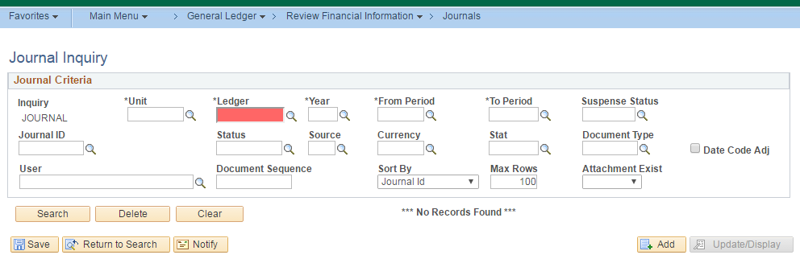

The search criteria for a journal search is simpler than a chart field search.

The “Unit” must always be “USF01”.

The “Ledger” must always be “Actuals”. Type this or search from the list.

Select the desired “Fiscal Year”. Search from the list (fiscal 2017 in this illustration).

Select the desired “From Period” and “To Period”. Note a good practice is to use “From
Period” 1 “To Period” 998.

Then enter the journal ID (APA0466601 in this illustration).

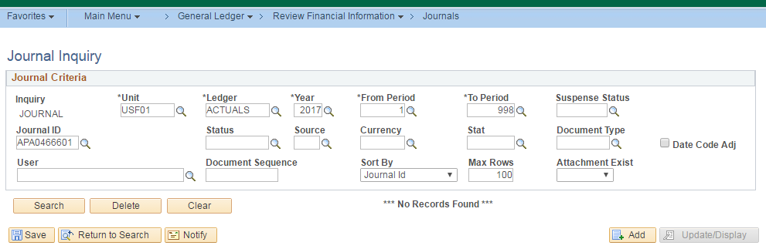

The search will reveal the journal with posting date and status.

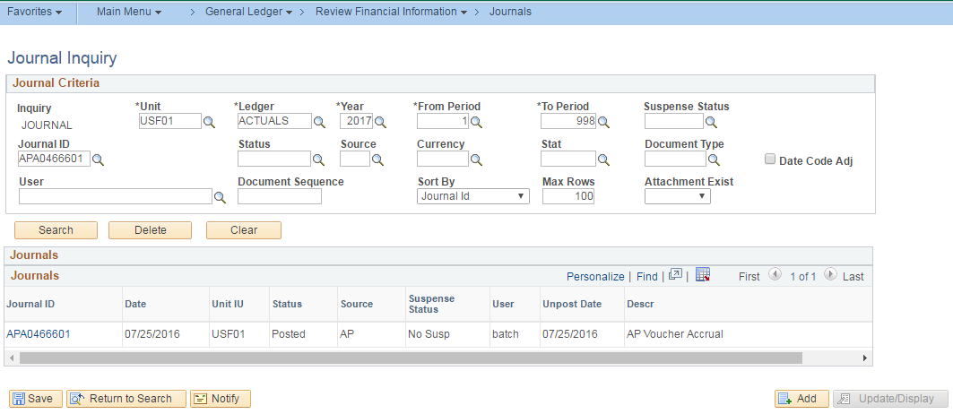

Click the Journal ID (hyperlinked in blue) to reveal the Journal Inquiry Details.

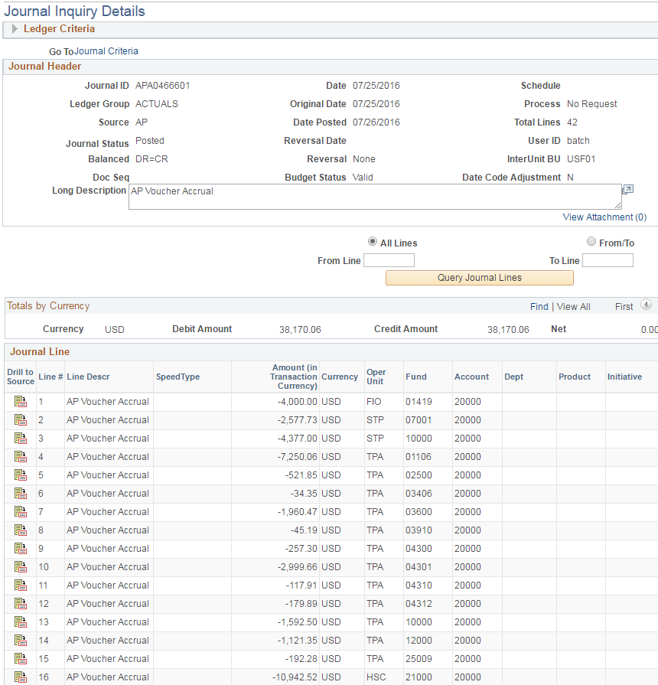

Note that the header of the page identifies the journal ID, posting date, and total number of lines.

The journal lines will appear in sequential order, 1 through 42 in this illustration. Especially when viewing a journal with a large number of lines, it is helpful to sort the data by chart field; fund ID or department ID for example. Simply click the chart field name (Fund for this illustration) to view the journal lines in fund ID order (next illustration).

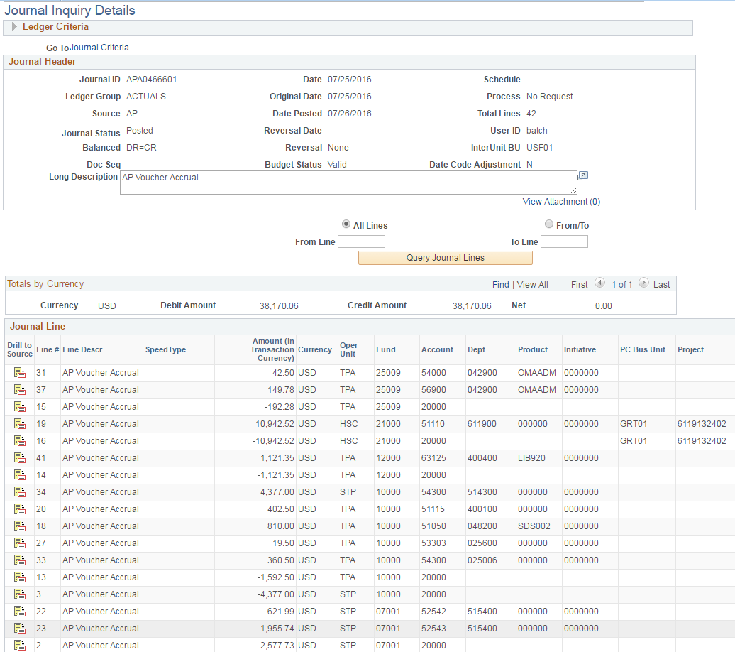

From the Journal Inquiry Details, continue your search as described on page 10 of this document.

Exploring Commitment Control

In FAST the Commitment Control module is used to analyze spending in relation to budget limits. Expense budget is released to individual chart field strings. Encumbrances from requisitions and purchase orders reserve and reduce the amount of budget remaining for use. Actual expenditures, whether from direct vendor payments or from Pcard charges also reduce the amount of remaining budget. The amount of remaining unencumbered, unexpended budget is referred to as RSA (Remaining Spending Authority).

The calculation of RSA is as follows:

Budget released to a chart field string
Minus requisitions encumbered
Minus purchase orders authorized
Minus vendor payments (both travel and non-travel related)
Minus Pcard charge payments made

Equals RSA

A report of RSA based on a chart field search will display all of these elements in a summarized view and by individual chart field strings in real time.

Reporting in Commitment Control requires that an inquiry name be established. From the navigation below, setup an inquiry name as described on page 2 of this document.

Navigation: Commitment Control/Review Budget Activities/Budgets Overview. After navigating and selecting the inquiry name, the Budget Inquiry Criteria page will appear.

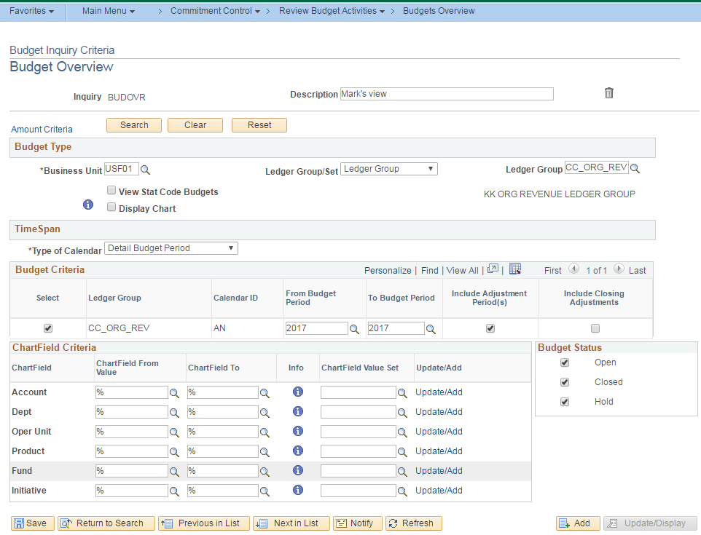

Key points to build a successful search.

The Business Unit must be “USF01”
Select the correct Ledger Group
Confirm the correct Fiscal Year appears
Select the correct periods
Check “Show YTD Balance”, “Include Closing Adjustments”, and “Include Period 998”

Be careful to select the correct Ledger Group. Several options will appear as in this image.
There are just four that should be used.

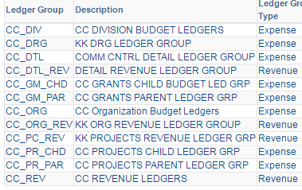

If searching for an RIA fund (initiative value) select the CC_DRG ledger group.

If searching for a sponsored research grant, select the CC_GM_CHD ledger group.

If searching for E&G state funding or for expenses on an auxiliary fund select the
CC_ORG ledger group.

If searching for revenue transactions on an auxiliary fund select the CC_ORG_REV
ledger group.

Use a minimal search with chart fields.

If searching for an auxiliary fund, use only the Fund ID
If searching for a department, use Fund ID and Department ID
If searching for a sponsored project, use only the Project ID to report
all activity including any cost share data
If searching for an RIA fund, use only the Initiative ID

The following is an illustration of a search for budget information for E&G fund 10000 for a department for the fiscal year 2017. Enter the chart field values in the “Chart Field From Value” column. It is not necessary to enter anything in the “Chart Field To” column. Click to create the report.

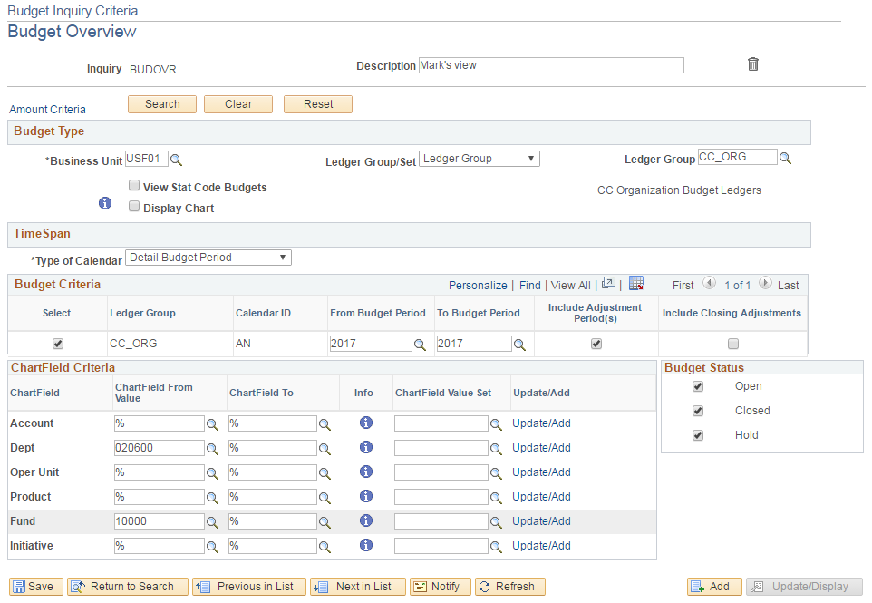

The Inquiry Results will present first with a summary followed by individual chart field string lines.

The summary will present the total budget released, the amount of actual expense posted, the current encumbrances (purchase orders), the current pre-encumbrances (requisitions), and the budget balance.

The individual chart field string lines will display the same elements with a “Percent Available” value represent the percentage of the total budget that is available for use (RSA).

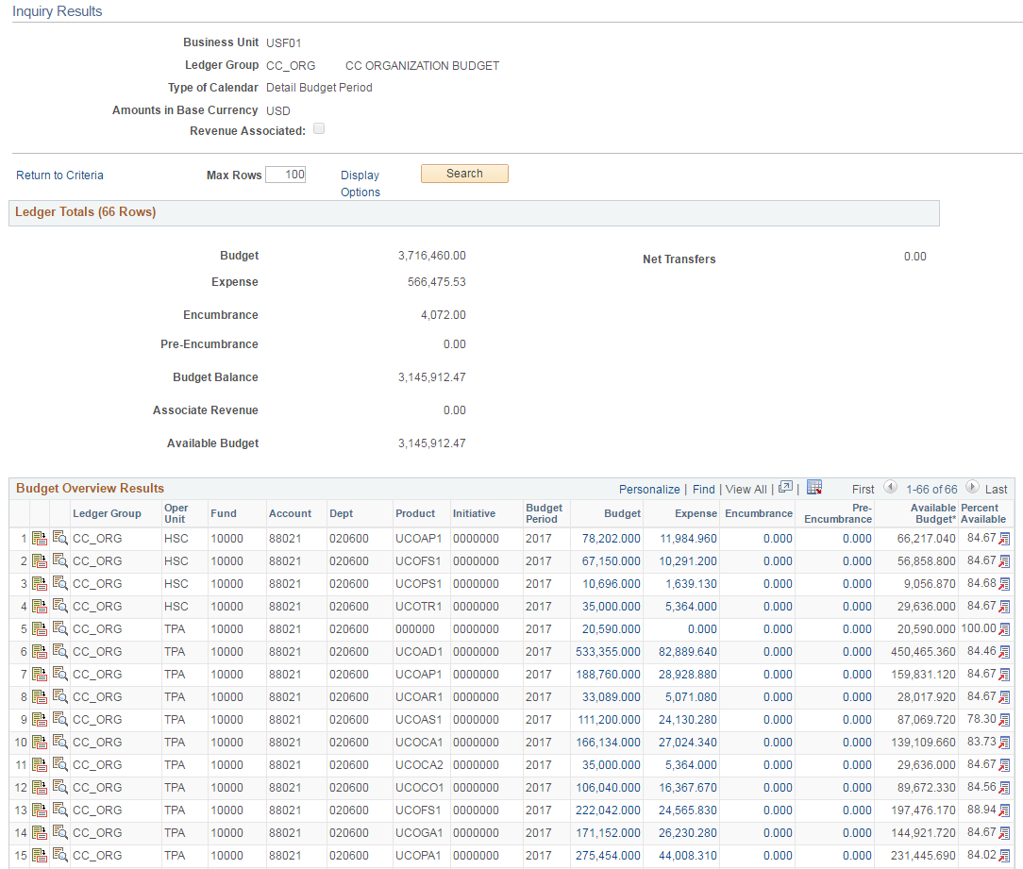

By clicking the actual budget dollar amount on any line will reveal all budget actions (allocations and reversals) that comprise that dollar amount.

For instance, clicking the dollar value $275,454 on line 15 of the illustration above will reveal the following details.

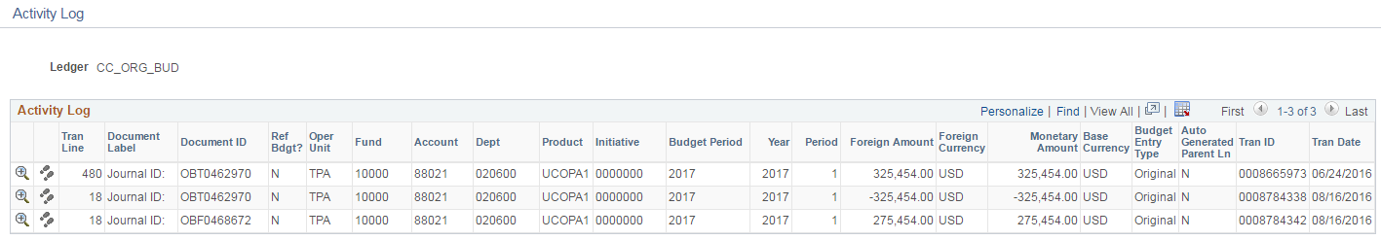

The “Activity Log” above reports three actions: the first line is a preliminary budget release dated 06/24/2016 followed by a reversal of that budget dated 0816/2016 and then followed by a new budget release also dated 08/16/2016.

Note that each line identifies the “Document (Journal) ID”, the transaction line within that journal, the chart fields, the budget period and year, the dollar amount, and the “Tran ID”. These are references will be needed if there are questions to pose about the budget actions.

Please note that this Commitment Control report is reliable information of budget releases and budget actions. Although amounts appear in the “Expense” column, it is a best practice to research expenses using the general ledger, not commitment control.

Frequently Asked Questions

• Do I need special security access to review General Ledger or Commitment Control?

You need nothing more than the basic Inquiry security role.

• What is the difference between the budget information in Commitment Control v. Finance Mart RSA?

The difference is timing. FAST Commitment Control reports budget information as of right now. The RSA Summary in Finance Mart reports budget information as of the close of business of the previous day.

• Can the data be downloaded to Excel?

Yes. As with most reports in FAST, look for the symbol on the report page. Click it to download the data on that page to an Excel spreadsheet.

Resources/Contact Information

Office of the Controller
Phone: (813) 974-6061
Fax: (813) 974-4485
www.usf.edu/business-finance/controller

General Accounting
Fax: (813) 974-2622
http://www.usf.edu/business-finance/controller/accounting-reporting/index.aspx

Training and Resources
http://www.usf.edu/business-finance/controller/about/training.aspx

Business Processes
www.usf.edu/businessprocesses

