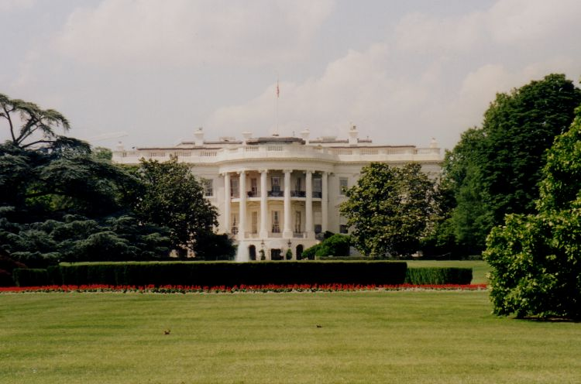

The Road to the White House

Internship Placements

Professor Judithanne Scourfield McLauchlan

727/744-8266

Democratic Presidential Campaigns

(1)

Brandon Keith

(2)

Damaris Escalera
Emilio Favale
Steven Lapinski
Danita Mouttaki
Larry Rodanski


(3)

Matthew Perlegis

(4)

Joel VanHorn


(5)

Sarah Summers
Joseph Spilatro


(6)

Andrew Wilson

Republican Presidential Campaigns

(7)

Maggie Bratcher
Laura Davis

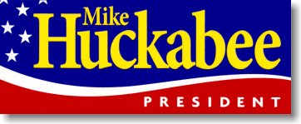
(8)

Rebekah Lee


(9)

Russell Leach


(10)

Shadi Fackih

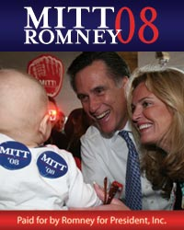
(11)

Scott Burrows Jr.
Laura Tomlinson
George Meehan

