Media Placements

Print: Television: Radio:
Creative Loafing ABC Action News WUSF 89.7
Tampa Tribune Bay News 9 WMNF 88.5
The Crow’s Nest NBC Miami WSMR 89.1
The Guardian WUSF
Tampa Bays 10 (CBS)
 Newspaper:

Mitch Perry. “USF St Pete Students Choose GOP Campaigns to Work on.” Creative Loafing 13 January 2012.
http://cltampa.com/dailyloaf/archives/2012/01/13/usf-st-pete-students-choose-gop-campaigns-to-work-on#.TxQiufnSRmx

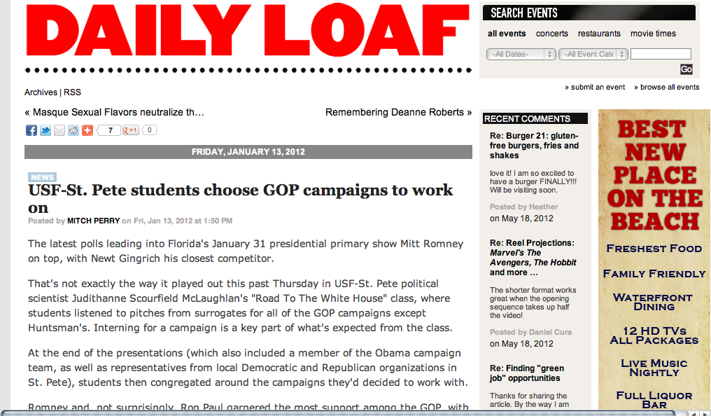

Dr. Scourfield McLauchlan was interviewd by Mike Salinero, “Gingrich Bills himself as Unifier.”Tampa Tribune. 25 January 2012.

Mitch Perry. "Hitting the trail: A USF St Pete Class Gets Hands on Experience in presidential campaigning." Creative Loafing. 26 Jan-1 Feb, 2012, pp. 23-24
http://cltampa.com/tampa/hitting-the-trail/Content?oid=2796135

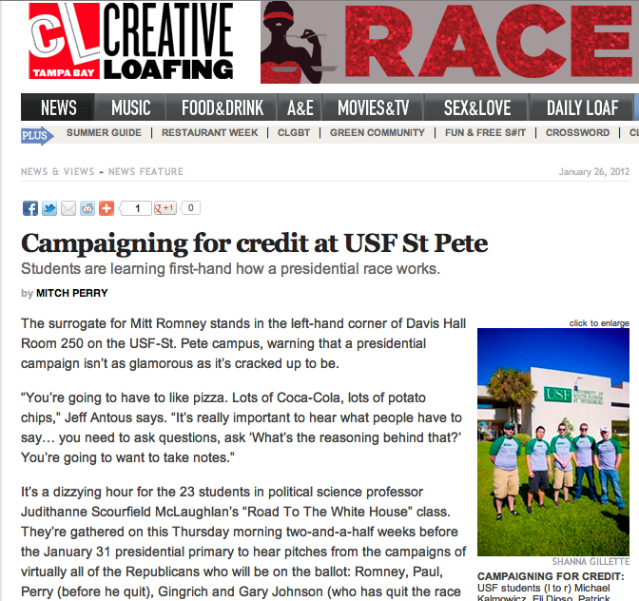

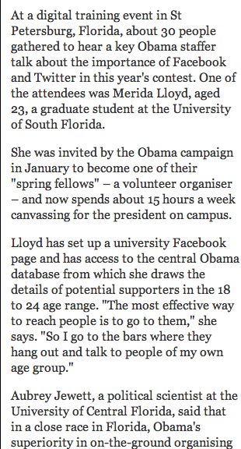
Ed Pilkington and Amanda Michel. “Obama campaign leaves Mitt Romney trailing as focus shifts to November.” UK’s The Guardian. 4 April 2012. http://m.guardian.co.uk/world/2012/apr/04/obama-campaign-romney-trails-november-election?cat=world&type=article
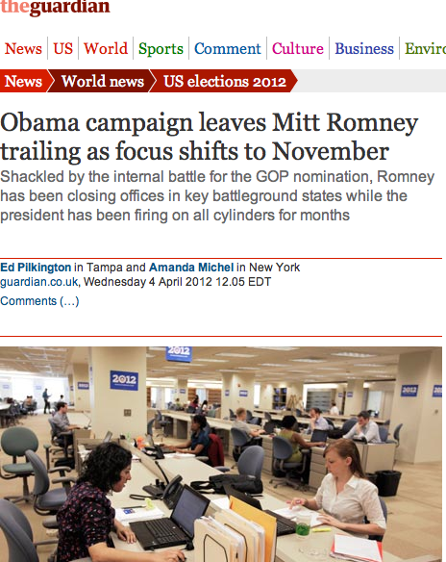

Amanda Pretulac. “Students take political journey in the spring 2012 class.” Crows Nest. 7 November 2012, pp 5

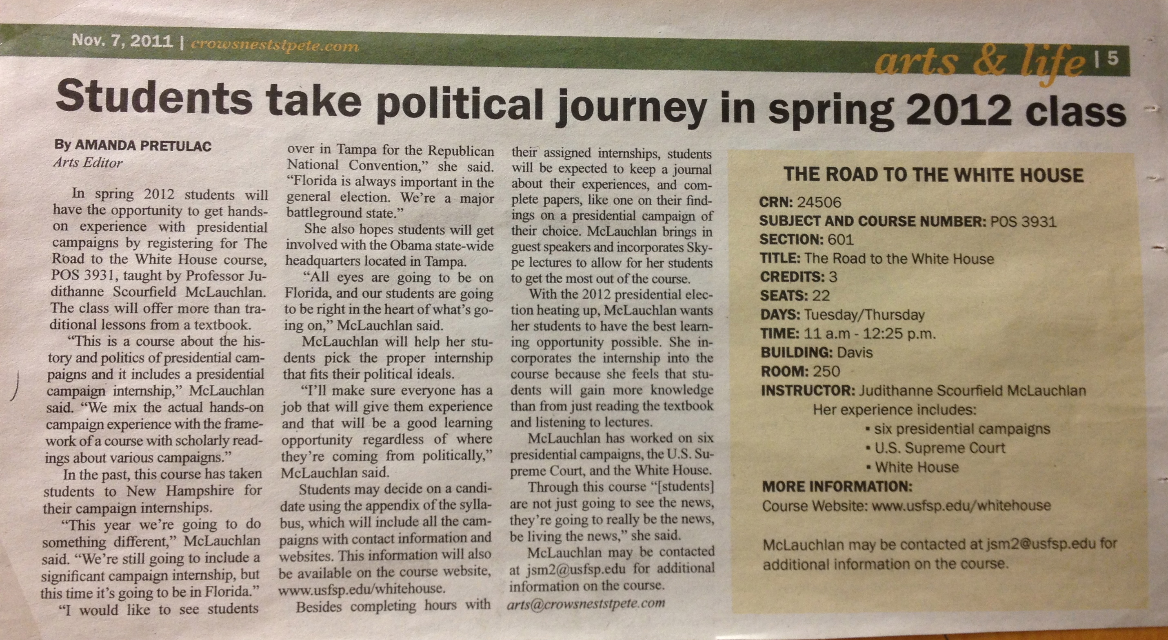

 Radio:
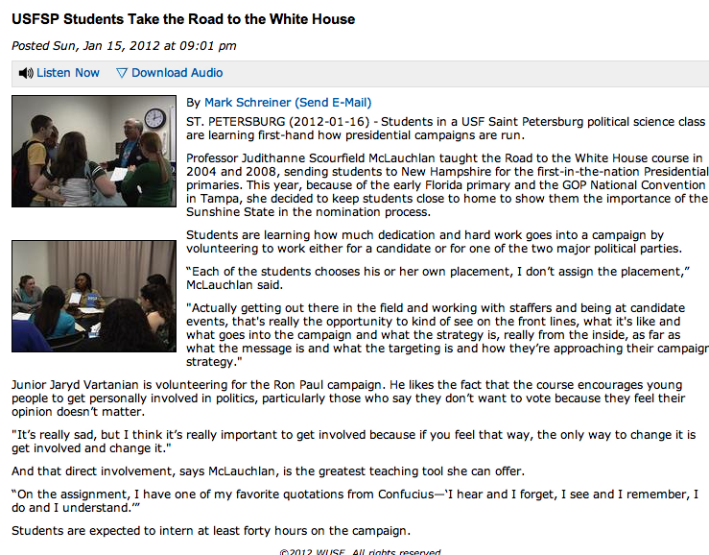
Mark Schreiner for “USFSP Students Take Road to the White House,” WUSF radio. 15 January 2012. http://www.wusf.usf.edu/news/2012/01/15/usfsp_students_take_the_road_to_the_white_house

Dr. Scourfield McLauchlan was a guest on WMNF radio, “Last Call Thursday” with Mitch Perry, 26 January 2012, 5 pm

WUSF University Beat featured the Road to the White House 2012 on WSMR 89.1 radio, WUSF 89.7 radio, and WUSF TV during the week of April 10, 2012.
http://www.wusf.usf.edu/radio/program/university_beat/episode/2012-04/road_to_the_white_house

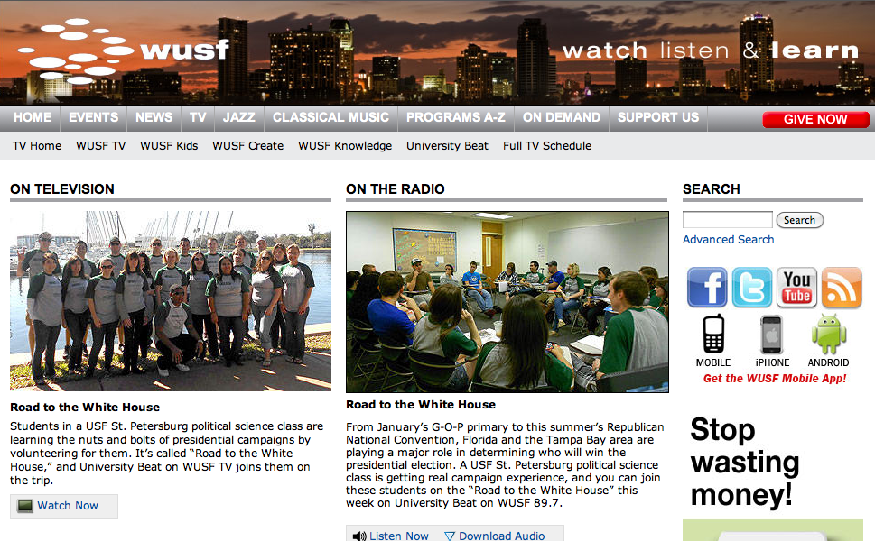

Television:

“USF Students Ready to Help Presidential Campaigns,” by Erik Waxler. ABC Action News. 12 January 2012.
http://www.abcactionnews.com/dpp/news/region_south_pinellas/st_petersburg/students-ready-to-help-presidential-campaigns

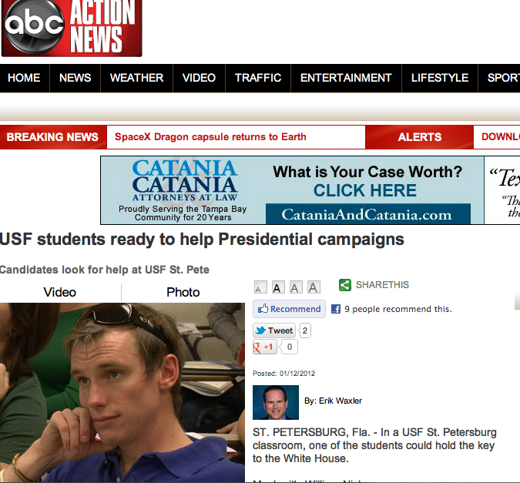

Bay News 9’s Dalia Dangerfield. “USF St Pete Students Taking ‘Race for the White House’ Class.” 13 January 2012.
http://www.baynews9.com/article/news/2012/january/369181/USF-St-Pete-students-taking-Race-for-the-White-House-2012-class#.TxAno3jBXGU.facebook

The Campaign Internship Job Fair in Road to the White House 2012 was covered by Tampa Bay’s 10. 12 January 2012.

Channel 10 News Story about Student Loan Rates, Interview with RTWH Student

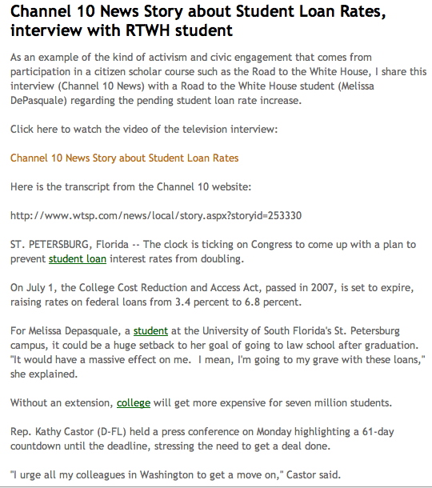

Dr. Scourfield McLauchlan was a guest on NBC-6 Miami’s Florida Primary Night Coverage with reporter Steve Litz. Live at the Romney Election Night Party. 31 January 2012.

Note: Links to these stories can be found on our website, www.usfsp.edu/whitehouse

.

